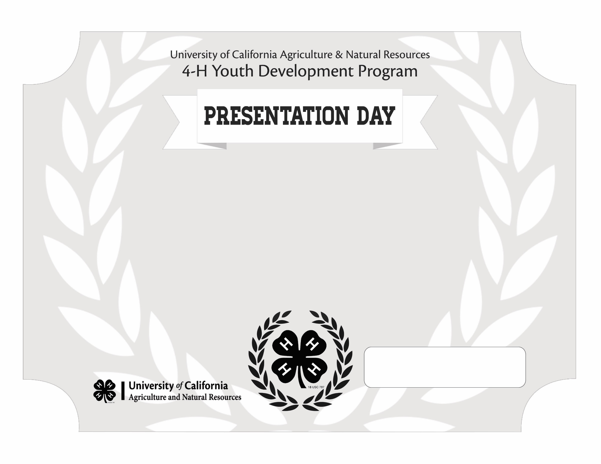

This certificate recognizes the participation of

Recipient Name

4-H Coordinator Date

in the [insert county or section] Presentation Day.