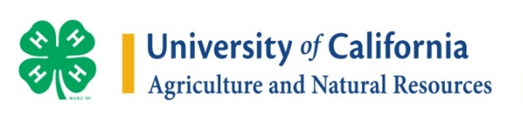
UC 4-H Latino Initiative
Program Description Cover Page

Program Begin Date |  | Program End Date
County
Name of Program
Meeting Location
Program Model | In-Motion Club  SPIN Club  SNAC Club  Short-Term Project  Day Camp  Other: ______________________________________
Enrollment Type | Individual  Group
Funding Source
Partners/Collaborators

Content
Core Focus | STEM  Healthy Living  Civic Education/Engagement  College/Career Readiness  Leadership  Other: ______________________________________
Curriculum

Educators
 |  | Number
Facilitators/Educators | UCCE staff
 | Collaborating agency staff
 | 4-H adult volunteers
 | 4-H teen volunteers
 | Other:________________
Training for Educators

Youth
Number of Participants
Age Range of Youth

Dosage
Number of Meetings |  | x Length of Each Meeting |  | = Total Hours

Individual Surveys included with this program
Youth |  | Volunteer
 | Number of surveys |  | Number of surveys
CM – Universal |  | Adult Survey  “Needs Assessment”
Program Quality |  | Program Quality
If applicable, mark below
CM - Science
CM - Healthy Living
CM - Civic Engagement
CM - Career/College Readiness

