UC ANR Single Sign On (SSO) authentication
required for UCPath access
To access the new UCPath system at http://ucpath.universityofcalifornia.edu, all UC ANR employees and affiliates must use ANR’s Single Sign On authentication.
After navigating to the UCPath website, please select “University of California, Agriculture and Natural Resources” to login.
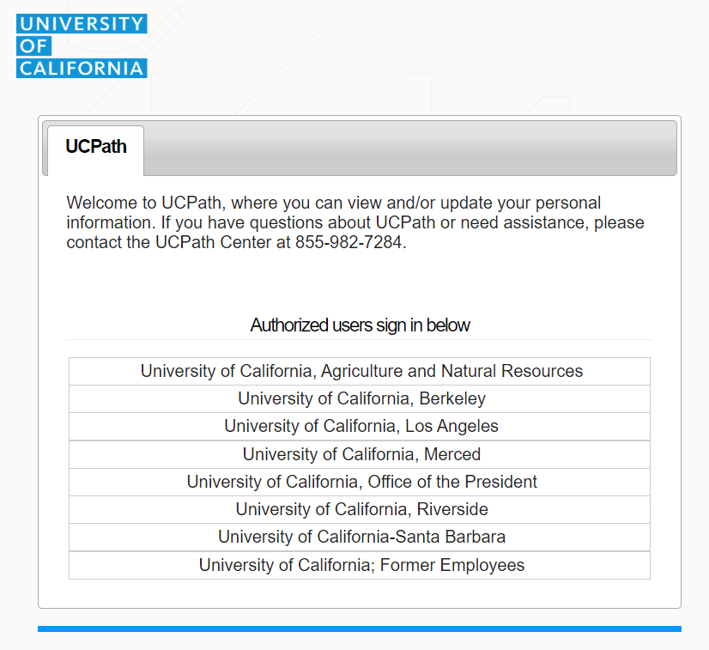
After selection, you will see UC ANR’s SSO page. Enter your UCANR username and password, the same as you use to access the UC ANR Portal.
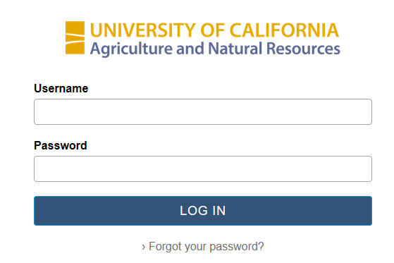
If your credentials are correct, you will now enter the UCPath system.

Forgot Your Password?
Please make sure you are entering the correct credentials, otherwise, click Forgot your password? link and follow next set of instructions.
Forgot Password page:
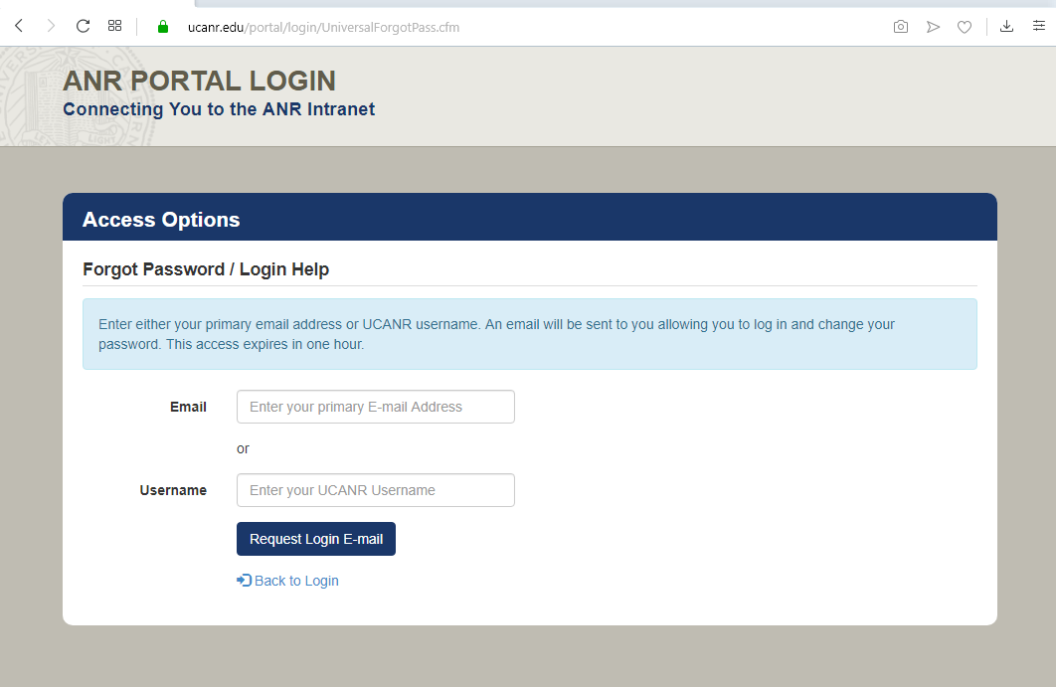
Passwords must be at least 12 characters long; not contain your account name or login ID; contain a mix of uppercase, lowercase, digits and symbols. If your password is not complex enough, you will get an error message like Active Directory password complexity not satisfied; unable to update account.

Once you get a Password Updated Successfully message, you should be able to log in to supported services, including the ANR Portal.

For Additional Support: (Please Contact)
- Email: help@ucanr.edu
- Web: https://ucanr.zendesk.com

