Saving Your Trees From Drought!

By Dr. A. James Downer
Drought of epic proportion is imperiling many western states this year. For the first time some water districts have proposed curtailment of all exterior irrigation, no applied water will be allowed outside of residences. There are public forums are scheduled with experts and officials giving advice. Of great concern is the certain loss of turfgrass swards but far more concern is being expressed for the loss of trees.
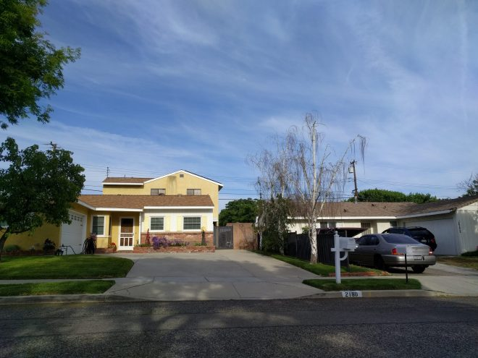Drought brings change in landscapes. Here European birch have died and provide opportunities for planting more drought tolerant species
Don’t assume your trees will die of drought!
Most established trees are resilient, they have built in drought avoidance and tolerance strategies. It helps to understand these processes and know the symptoms of drought injury in trees. Almost all trees will stop growing when they enter drought conditions because there is not enough water to produce the turgor pressure necessary to expand cells. While growth may slow, trees have root systems that help prevent them dying of drought. The root systems, while mostly in the surface layers of soil, also explore greater depths where they can extract water from larger volumes of soil. So even though soil may be dry on top, trees have greater access to moisture than is obvious from above. Trees also have mycorrhizal fungi that help them extract water bound tightly to soil. When these strategies become limiting, tree roots produce abscisic acid that flows to the pores in leaves and closes them to reduce transpiration. If drought continues, many trees will drop leaves entirely to help stem and root tissues survive, thus avoiding drought. These mechanisms are all controlled by tree genetics and their ability to ameliorate drought effects is variable. Some trees are just more drought resistant than others.
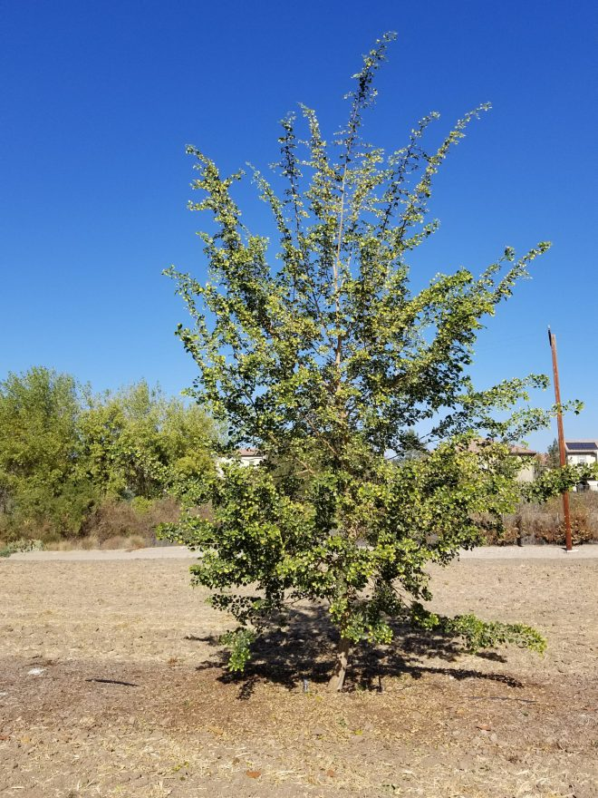
Some trees such as this Indian rosewood (Dalbergia sissoo) are adapted to hot climates and endure long dry periods without damage.

Don’t plant new trees in the Summer!
Now is not the time to plant trees. As we near June 20th (the longest day of the year) demand for water is also greatest as sunlight drives photosynthesis and thus water use by trees. Newly planted trees all need irrigation to help them establish. During drought years, wait until later fall months (when rain is more likely and day length is decreasing) to schedule planting.

Don’t fertilize trees during drought!
Fertilization is the last thing you want to do during or at the onset of drought! Fertilizer (organic or inorganic) contains salts that increase the osmotic potential around roots. This alone can create “physiological drought” as water is drawn out of roots into soil solutions. Fertilizers should only be applied when known deficiencies are present and water is abundant enough to dissolve the applied materials. Fertilizers increase drought stress for trees if water is not available for the application. 
Don’t prune trees during drought!
Pruning removes terminal buds that regulate growth of the canopy. When they are removed by pruning, lateral buds are released to grow. Stimulating new growth during drought is a disaster for trees. Don’t do it! You may falsely think removing branches in a tree canopy will save water. Most trees can regulate their own water loss as discussed above or by dropping leaves as necessary when dry conditions ensue.
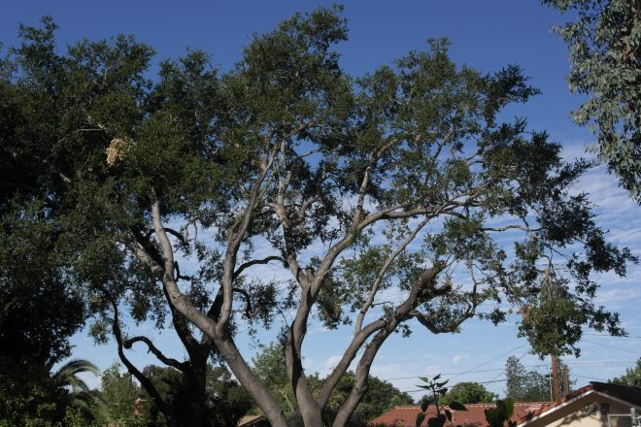Pruning, especially over-thinning, stimulates new shoots to grow–something you do not want to encourage during drought periods
Do not install artificial turfgrass
Artificial turfgrass is not a solution for hot dry conditions. In some cases it may exacerbate the situation. Artificial turfgrass does not allow percolation and capture of water since it covers soil. Artificial turfgrass does not transpire, so landscapes will not be cooled by it. Trees adjacent to artificial turfgrass have less ability to access water than those adjacent to a mulched area.
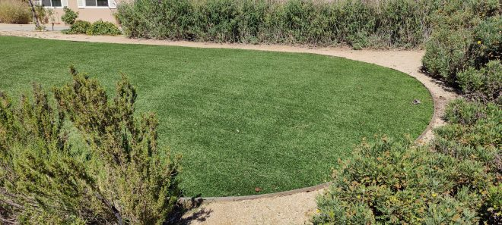Artificial turfgrass does not use water but it also gets hot. On the day this image was taken it was 50 degrees hotter than irrigated turfgrass and 30 degrees hotter than brown dry turfgrass
The longest day in June may not be the most stressful for trees
When water is scarce, it is important to apply it strategically to reduce tree stress. Even though June has the longest day and potentially tress will transpire the most, it may not be the most stressful time for trees because water may still be available at lower soil levels in June. As we enter later summer and early fall, stress builds as available water is depleted from tree root zones. Deciduous trees will lose leaves but evergreen trees or trees that can’t shed their canopy may begin to enter their permanent wilting points. This is usually proceeded by wilt, dieback, and loss of color. This is a critical point where strategic water applications can help trees through a critical period.
Do apply Arborist Chip Mulches
Mulch is a critical drought survival tool for trees. It is best if mulch is already in place but it is never too late to apply it. Mulch changes soil structure allowing for more water storage. Over time, mulched soils become more drought resilient. In the short term mulch prevents evaporation from soil surfaces so that applied water stays applied in the soil and is not lost. Coarse wood chip mulches prevent weeds that use water thereby keeping more moisture in the soil. Wood chip mulches support the mycorrhizal fungi that help trees survive.
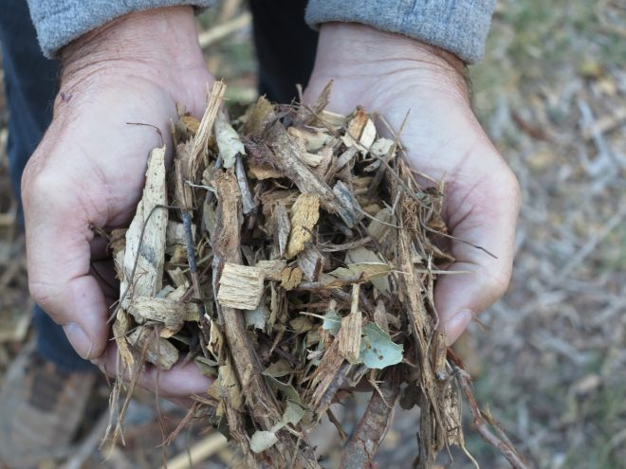A common theme in these blogs: arborist chips straight from the chipper have real benefits for trees trying to survive drought
Do “top up” existing mulched areas around trees
Mulch breaks down as it is supposed to. It is important to keep mulch layers intact by occasionally adding to mulch layers. If you have not done so, add mulch before summer gets too far along.
Do remove lawns or shrubs that are no longer sustainable in the landscape with care.
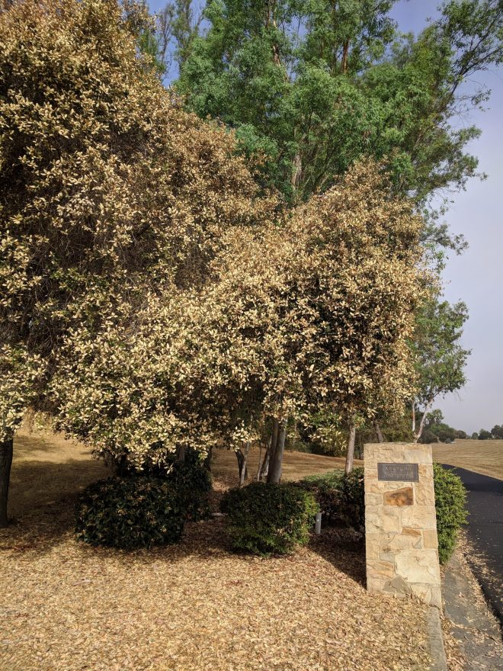Due to climate change, coast live oak (a native) is less adapted to inland valleys of Southern California than Eucalyptus camaldulensis (an exotic).
Water restrictions, hot weather and dry soils culminate and can greatly damage landscapes. If landscapes are over planted or there are unwanted/unnecessary plantings they can be removed to save the water they would use. Be careful not to expose existing plants and trees to bright sunlight as this may cause them harm from sunburn. Be careful removing turfgrass swards and the irrigation that accompanies it because adjacent trees may be reliant on the excess applied water. A slow dry down and mulch over process may be the best approach to save valuable perennial plantings near unsustainable turfgrass.
Do monitor your trees for signs of impending drought stress. and apply water in a timely manner
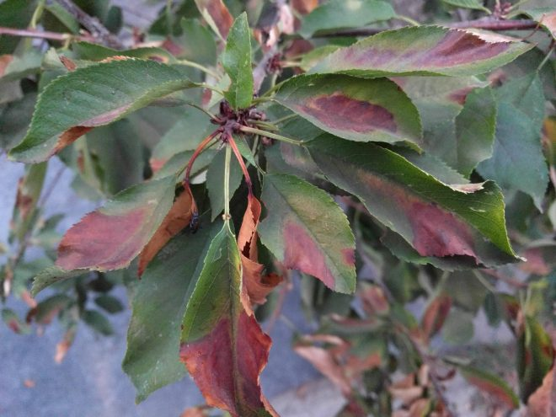High temperature injury to cherry leaves is not a symptom of drought but heat intolerance. However, as trees dry down they have less ability to endure high temperatures.
Wait until leaves start to turn yellow prematurely or canopies show wilt symptoms to apply water. As drought symptoms develop, consider a slow application of water by a dripping hose (moved frequently) or a low flow sprinkler that applies water only as fast as the soil can take it in. Apply water at night to cut down evaporation loss. Continue to monitor for further drought symptoms and spread out irrigation as needed to conserve water.
Do turn off your valve controllers to avoid over application of water.
Don’t let electronic devices make irrigation decisions for you during water restrictive drought periods. No electronic system completely understands the stress conditions around trees and will not be able to accurately predict when to irrigate. It is best to make these decisions based on your own assessment of conditions and resources available. Many “irrigation clocks” rely on regular frequent applications of water to keep soil moisture supplied. Frequent short run cycles replace water used by plants. During drought restrictions, controllers need to be reprogrammed to apply less frequently but for longer runs (to the point of run off) or not used at all if the sprinkler emitters put out too much water. Targeted water applications will likely be necessary and valve controllers will need to go “dormant”, i.e., turned off.
Be hopeful
Droughts come and go, right now they keep coming. But there are many examples of trees that only receive rainfall, no applied irrigation and yet survive well. Don’t assume your trees will die of drought. This may be a time to remove trees that are not adapted to growing in your area and drought conditions will reinforce this. European Birch are certainly disappearing from many landscapes this year in Southern California. Increase the use of mulch, apply water strategically, and consider planting more adapted trees late in fall or winter when water is available to support establishment.

