Ventura County Garden to Table Series –

Onions and Other Alliums- Recipes

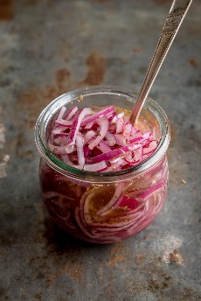

* + Marinated onions - <https://www.kitchensanctuary.com/marinated-onions/>
  + French onion soup - [www.wellplated.com/french-onion-soup/](http://www.wellplated.com/french-onion-soup/)
  + Caramelized onion dip – <https://www.howsweeteats.com/2021/04/caramelized-onion-dip/>
  + Garlic paste - <https://www.alphafoodie.com/how-to-make-garlic-paste/> - store in the freezer
  + Garlic infused olive oil - [https://www.alphafoodie.com/garlic-infused-olive-oil/#wprm-recipe-container-81512](https://www.alphafoodie.com/garlic-infused-olive-oil/)
  + Shallot Vinaigrette - [https://www.annielucey.com/recipes/lemon-shallot-dijon-vinaigrette#recipe-card](https://www.annielucey.com/recipes/lemon-shallot-dijon-vinaigrette)
  + 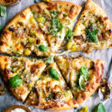Caramelized leek pizza w/ spicy honey – <https://www.theoriginaldish.com/2021/05/21/caramelized-leek-pizza-with-spicy-honey/> - you can add prosciutto or mushrooms.
  + Baked onions with fennel breadcrumbs - <https://www.foodandwine.com/recipes/baked-onions-fennel-bread-crumbs>

Note: several recipes I found online are not necessarily for the home grower of onions and other alliums. Please keep in mind that when you use fresh – from your garden – you may not have the exact variety as the recipe – but don’t be afraid to experiment.

Happy cooking – see you at the next class – Terry.