

Ventura County Garden to Table Series –

Greens Year Round - Recipes

Leafy greens can be eaten raw as well as sautéed, stir-fried, steamed, incorporated into soups, stews, pasta, or pizza, and added to smoothies. Discover the many ways to enjoy leafy greens in your meals. Here are some recipes to get you started.

  - Spinach Risotto – substitute kale, Swiss chard, or non-traditional spinach https://instantpot.com/blogs/recipes/mushroom-and-spinach-risotto
  - Kale Enchiladas https://www.tippsinthekitch.com/green-chile-chicken-kale-enchiladas/
  - or tacos https://darshanaskitchen.com/kale-tacos/
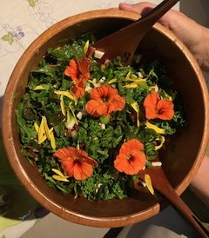

- Pesto – use kale, spinach, Swiss chard, or even beet or carrot tops https://www.lifeisbutadish.com/easy-spinach-pesto/
- Cabbage for a Healthy Slaw https://feelgoodfoodie.net/recipe/healthy-coleslaw/
- Homemade Sauerkraut - https://www.wyseguide.com/homemade-sauerkraut/
- Garlic Bok choy - https://theforkedspoon.com/bok-choy-recipe/

Of course – there is nothing better than a fresh leafy green salad from your garden.

Note: several recipes I found online are not necessarily for the home grower of greens. Please keep in mind that when you use fresh – from your garden – you may not have the exact variety as the recipe – but don’t be afraid to experiment.

Happy cooking – see you at the next class – Terry.

