Ventura County Garden to Table Series –

Root Vegetable - Recipes

From humble beginnings beneath the soil, root vegetables emerge as versatile ingredients that add depth, nutrition, and unexpected flair to a wide range of dishes.

Note: several recipes I found online are not necessarily for the home grower of greens. Please keep in mind that when you use fresh – from your garden – you may not have the exact variety as the recipe – but don’t be afraid to experiment.

* + A couple jars of food

    Description automatically generatedBeet (or Carrot) Salsa - [http://www.paleocupboard.com/beet-salsa.html#google_vignette](http://www.paleocupboard.com/beet-salsa.html)
  + Roasted Root Vegetables (you can even roast radishes) - [https://www.loveandlemons.com/roasted-root-vegetables/#wprm-recipe-container-66582](https://www.loveandlemons.com/roasted-root-vegetables/)
  + 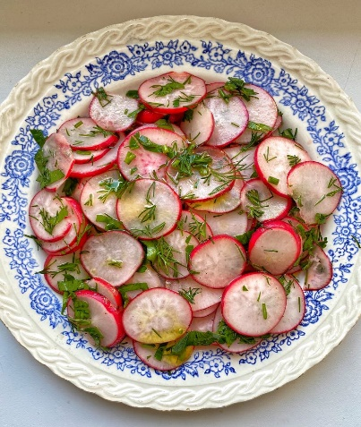Carrot Ginger Soup - <https://www.delish.com/cooking/recipe-ideas/a38760973/carrot-ginger-soup-recipe/>
  + Pickled Turnips (or just about any root vegetable) -<https://www.rachelcooks.com/pickled-turnips/>
  + Fresh Radish Salad - <https://tastysimplyvegan.com/fresh-radish-salad/>
  + Root Tops – as a substitute for greens – in salads, pesto, steamed…

And of course we can’t forget – Carrot Cake - <https://www.inspiredtaste.net/25753/carrot-cake-recipe/>

Image Courtesy of tastysimplyvegan.com

Happy cooking – see you at the next class – Terry.