Sample Figure List for an ANR Publication

To see the thumbnails, view in Print Layout mode. Note that CS staff will fill in the last column (“Filename”)

Fig. | Thumbnail | Caption | Credit | AU filename | Filename
16.1 | 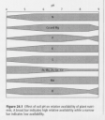 | Effect of soil pH on relative availability of plant nutrients. A broad bar indicates high relative availability, while a narrow bar indicates low availability. |  | Walnut manual 3373 fig 24.1
16.2 | 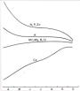 | Generalized shapes of nutrient concentration curves of prune leaves during the growing season. Trends, not actual values, are shown. | Source: Uriu 1981. | redraw
16.3 | 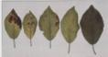 | Potassium deficiency symptoms in prune leaves. A normal leaf appears at far right. | Photo: D. Edwards. | Plate 16.001
16.4 | 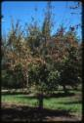 | A severely potassium-deficient prune tree in midsummer showing extensive leaf scorching in the md to upper canopy. | Photo: D. Edwards. | Plate 16.002
16.5 | 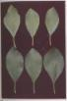 | Nitrogen-deficient compared with nitrogen-sufficient prune leaves. The deficient leaves are in the top row, the sufficient leaves are below. | Source: Uriu 1981. | Plate 16.003
16.6 | 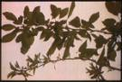 | Zinc-deficient compared with nitrogen-sufficient prune shoot. | Photo: D. Edwards. | Plate 16.004
16.7 | 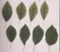 | Manganese-deficient prune leaves. | Photo: D. Edwards | Plate 16.005
16.8 | 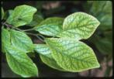 | Prune leaves showing iron deficiency symptoms, with virtually complete interveinal chlorosis compared with that from manganese deficiency seen in figure 16.7. | Photo: D. Edwards. | Plate 16.006
16.9 | 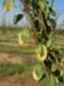 | Magnesium deficiency symptoms in young prune trees. | Photo: D. Edwards. | Plate 16.007
16.10 | 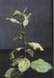 | Extreme sulfur deficiency symptoms in prune. | Photo: D. Edwards. | Plate 16.008
16.11 | 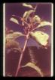 | Copper deficiency symptoms in prune. | Photo: D. Edwards. | Plate 16.009

