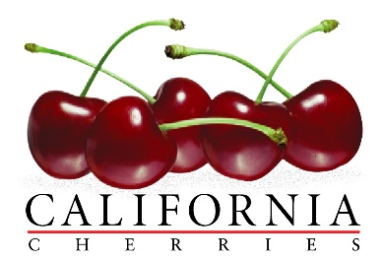

CALIFORNIA CHERRY BOARD

RESEARCH GRANT PRE-PROPOSAL TEMPLATE

Last Revised: 08/27/2020

SUBMISSION DEADLINE: Friday, September 25, 2020

REQUIRED PRE-PROPOSAL CONTENT

Institution/Organization:

Department/Division:

Project Year: Anticipated Duration of Project (yrs.):

Principal Investigator(s):

Cooperating Personnel:

Project Title:

Commodity:

Pre-proposal format: Microsoft Word format; 11 pt. Times New Roman; do not include page #’s, headers or footers; “normal” margins: 1” left, right, top and bottom margins; total length of proposal ≤ 3 pgs. (not including supplemental attachments).

Problem and significance: Compose a limited literature review of the subject or problem to be investigated: include citations (ie. literature; industry correspondence; etc.). Describe the significance or need for the research.

Objectives: Identify the specific research objectives or goals that you hope to achieve during your project. Indicate how the research objectives or goals meet the priorities identified by industry.

Expected outcomes: Provide a concise summary of the expected findings of your research project and how the expected findings may benefit the California sweet cherry industry. Indicate what you will need from industry for your project to be successful.

Budget: Use the below “RESEARCH GRANT PRE-PROPOSAL BUDGET WORKSHEET” to list the total amount of requested funds for each year of the project – a more detailed budget worksheet and project methodology will be asked to accompany any submission of a full proposal.

RESEARCH GRANT PRE-PROPOSAL BUDGET WORKSHEET

Contract administrator:
Email:
Telephone:

Project Year | Annual Budget Request ($)
2021-22
2022-23
2023-24
2024-25
Total Budget Request:

Originator’s signature (PI): Date:

Authorized signature: Date:

