
Display | Script | Additional Content | Visuals Needed
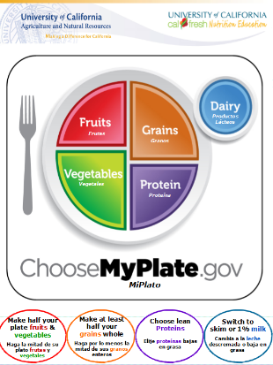  Left Panel | Question: How many types of fruits and vegetables do you eat in a day?  Discussion:  Fruits and Vegetables  - Make half of your plate fruits and vegetables  - Eat red, orange and dark-green vegetables such as tomatoes, sweet potatoes, and broccoli in main and side dishes.  - Darker vegetables have more vitamins and minerals. | Physical activity with Phytofrenzy cards. | - Plastic food models  - Phytofrenzy cards
Left Panel | Question: What types of grains do you eat in a day?  Discussion:  Grains  - Make at least half of your grains whole  - Choose 100% whole grain cereals, crackers, rice, tortillas, grits and pasta.  - Check the ingredient list on the food package to find the word “whole grain” | A grain: any food made from wheat, rice, oats, corn meal, barley, millet, quinoa or another cereal grain.  Whole grains include all 3 parts of the grain bran, germ, endosperm | - Grain model  - Grain labels-read ingredients  - Real grains
Left Panel | Question: What is your favorite protein food?  Discussion:  Protein  - Include seafood twice a week.  - Choose lean red meat, chicken and turkey  - Remember to choose natural protein options such as; beans, nuts, and soy. | Seafood: tilapia, tuna, crab, salmon, trout, sardines, oyster, clams, shrimp, lobster, muscles, mackerel, herring.  Keep portions small (no larger than size of your closed fist)  Discuss protein comes from 2 main sources, plant or animal  Protein helps our body to build strong muscles. | - Show visuals and have participants vote on if the source is plant or animal
Left Panel | Question: Why do gallons of milk have different colored caps? (they indicate the different fat levels)  Discussion:  Dairy  - Switch to nonfat or 1% low-fat milk instead of whole milk  - Nonfat or low-fat 1% milk contain the same amount of calcium as whole milk without the fat  - Alternatives to dairy foods that contain calcium | Discuss calcium and its importance for bone and teeth health  Foods: calcium-fortified cereals, juice, soy products, almond milk; dark leafy green vegetables, canned fish | - Milk labels from whole, 1%, nonfat
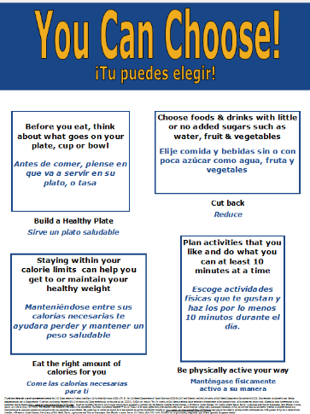  Center Panel | Question: What type of physical activity you enjoy?  Discussion:  Physical Activity  - Do ten minutes at a time of your favorite physical activity throughout the day to reach your 30 minutes.  - Physical activity has numerous health benefits.  - Your children pay more attention to what you do then what you say, BE A ROLE MODEL! | Adults: 30+ minutes  Children: 60+ minutes  Examples; walk after dinner, during a break or taking children to and from school, wash car, or anything that gets you moving.  Benefits: maintain healthy weight and muscle and bone strength, reduces your risk for chronic disease, increases energy and helps you sleep better at night | - Do some physical activities out of the ESBA Physical Activity Book
Center Panel | Calories  Eat the right about of calories for you.  - Staying within your calorie limits can help you get to or maintain your healthy weight. | UC CalFresh does not provide daily recommendations.  Visit choosemyplate.gov for calorie recommendations
Center Panel | Cut back on added salt, sugar and fat  - Choose foods & drinks with little or no added sugars such as water, fruit & vegetables.
Center Panel | Build a healthy plate  - Before you eat, think about what goes on your plate, cup or bowl
Right Panel  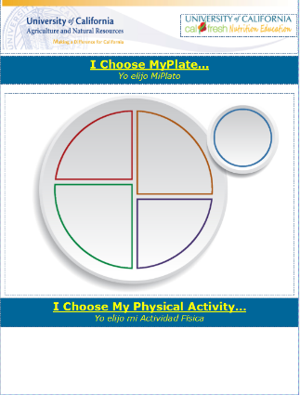 | Participants get to build a healthy plate & select a physical activity they plan to do. |  | Velcro pictures

