5 Ways to Save Workshop
Learning Goals
- Become familiar with 5 strategies to save money on nutrient dense foods.(5 Ways To Save)
- Identify nutrient dense foods using the nutrition facts label. (High or Low)
- Identify which meal cost less; meals made at home or eating out. (Which One Costs Less)
- Become familiar with the concept that making foods at home allows you to control the ingredients. (Which One Costs Less)
High or Low Poster
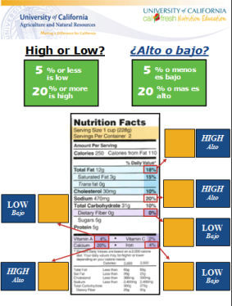
Opening Question:
- Have you seen a nutrition facts label before?
- Do you use the nutrition facts label?
Discussion:
- Refer to the sample package and point out where to find
the nutrition facts label.
- Identify that 5% or less is low and 20% or more is high.
- Explain which nutrients you want to have high and which
you want to have low.
  - High: fiber, vitamins, minerals
  - Low: sodium, fat

5 Ways to Save Poster

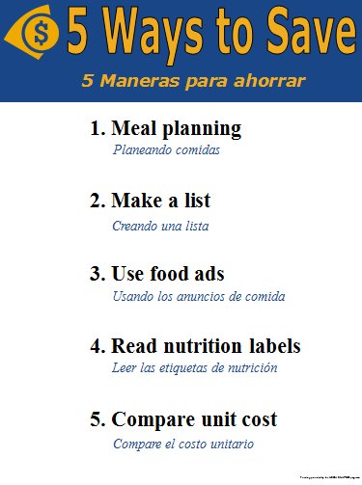
Opening Question:
- When you go to the grocery store do you take a list?
Discussion:
There are ways to save money while feeding your family healthy foods.
- Meal planning: Helps to save money by planning
ahead and buying in bulk.

- Make a list: Reduce buying things you don’t need
but see while shopping.
- Use food ads: See what’s on sale and plan your meals using those foods to help save money.
- Read nutrition labels: Select foods for your family that have nutrients that are high in fiber, vitamins and minerals and low in fat and sodium.
- Compare unit cost: Helps you to see if buying in bulk saves you money.

Which One Costs Less Poster
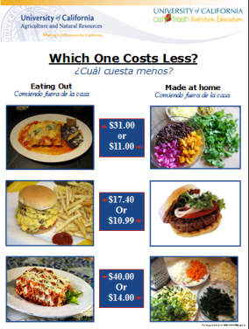
Opening Question:
- Where is your favorite place to eat out?
Discussion:
- Ask participants “Which costs more for a family
of four?” eating out or made at home.
- Reveal the answers after they guess and discuss how
eating at home is not only cheaper but allows you to
control what you put in it.
- Example: Adding vegetables to your enchiladas, using
2% cheese to cut down on fat, and controlling how much
salt you are adding.

Youth Activity
- Give each child a picture of foods and have them go and put them in the correct food group on the MyPlate mat.
Behavior Change
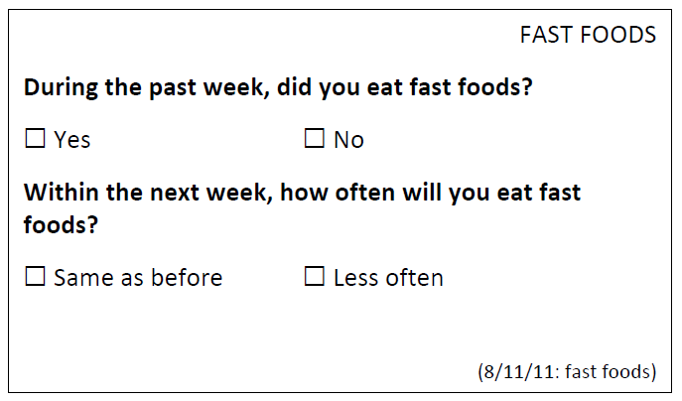
- Ask the participants “what is one change that they plan to make after learning this information?”
Complete intent to change form (see example)

Ask to sign-up for class series

