UC Master Gardeners of Colusa County
Plant Clinic and Garden Resource Information
Where?
Griff’s Feed and Seed
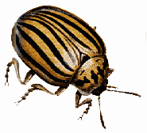7th and Fremont
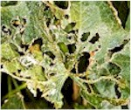Colusa
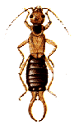When?
Friday April 11
10 am to 4 pm
What?
- Bring a sample of your plant problems
- Get answers to gardening questions
- Save water in your garden and landscape

