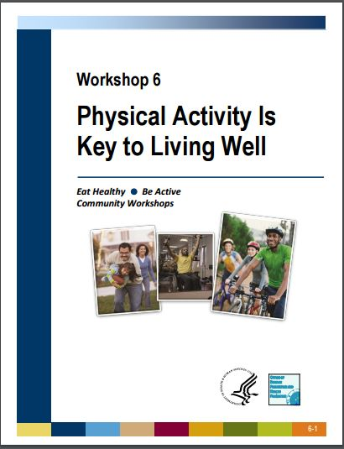

Workshop 6 Supplemental Lesson Guide

Introduction:
- Start the lesson by explaining how today’s lesson will focus on physical activity. Go over the learning objectives. Ask the class what they know about physical activity.
  - Next teach the class how to find their pulse. The radial pulse is often the easiest way to check your pulse.
  - Do not use your thumb when checking your pulse as it will alter your readings.
  - Place the index and middle fingers at the base of the thumb, then slide down about an inch to the groove of the wrist and press lightly. Start the timer for 6 seconds. Multiply participants reading by 10 to find beats per minute (BPM)
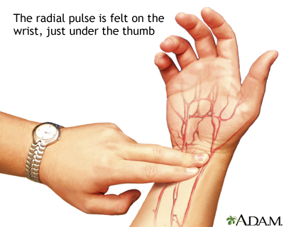
Image Source- https://medlineplus.gov/ency/imagepages/19395.htm
  - Explain to the class that this is their resting heart rate.
  - 60-100 BPM is the average (http://www.heart.org/HEARTORG/HealthyLiving/PhysicalActivity/FitnessBasics/Target-Heart-Rates_UCM_434341_Article.jsp#.WKY4WlUrLIU)
  - The lower the resting rate the better: well-trained athletes= 40-60 BPM
  - Tell the class that we are going to track how their heart rate changes during the lesson and the various activities included in this lesson.
- Play the “Find Someone who” icebreaker activity.
  - Make sure the class does a walk and talk
  - Have the class take their pulse after the activity and write down the average under warm-up.
  - Note the differences in heart rates as compared to the resting heart rate.
  - Explain to the class how it is important to Warm-up before exercising because it provides the following benefits:
    - Steadily increases heart rate to a safe level
    - Warms up the muscles safely
    - Prepares the body for more intense movements
  - Explain that the previous activity, walking, can be used as a general warm-up before they exercise or it can simply be their way to exercise depending on their fitness level. Warm-ups are any activity that steadily and safely increase your heart rate. Depending on your fitness level you may use jogging or jumping jacks as a general warm-up.
Being Active Your Way:
- Review the first page of the handout with the participants.
  - How do I do it? Others may ask what kind of physical activity should I do or what is the most effective exercise? These questions all have the same common answer, the best physical activity is whatever you will realistically adhere to or something you enjoy doing. Different things work for different people and all of our bodies are different. Some may enjoy running while others may not. Some may enjoy lifting weights or playing sports while others may not. It is up to you to decide what kind of physical activity you want to do. Do what you enjoy.
  - Describe the different types of physical activity;
    - Aerobic or Cardiovascular Exercise: Exercise that increases your heart rate and respiration. This exercise makes your heart lungs, and blood vessels stronger and more fit. Examples: running, swimming, walking.
    - Strengthening or Resistance exercise: any exercise that causes your muscles to contract. External resistances from resistance bands, free weights, machines, or body weight can be used in this type of exercise.
    - Flexibility and Balance Exercises:
      - Flexibility exercises stretch the muscles and increase your flexibility. This type of exercise may help relieve tension and tightness as well as reduce injury.
      - Balance exercises are exercises that improve a person’s ability to stably balance oneself.
  - Why should I be physically active? Ask the class what they think the benefits of physical activity are. After discussion, detail the benefits of exercise as provided by the Physical Activity Guidelines:
    - Increase your chances for living longer.
    - Decrease risk of heart disease, type-2 diabetes, high blood pressure, high cholesterol, stroke, and some types of cancer.
    - More restful sleep.
    - Fights depression by giving a person purpose and confidence.
    - Builds strength (this will be expanded on later in the lesson).
    - Maintain a healthy weight.
    - Have fun! Exercise doesn’t always have to be a tedious process.
  - How many times a week should I be physically active? As long as it adds up to 2 hours and 30 minutes a week and you do it at least 3 days a week. Inform the participants that more is always better though. The more they exercise the more they will see and feel the associated health benefits. Try to be as active as possible. Every little bit counts.
  - How do I build up more physical activity? Start slow. Don’t overdo it. Make small sustainable changes that will become life-long changes. Progressively and safely increase in difficulty and duration. Do what you are comfortable doing.
- How much physical activity do I need to do?
  - Aerobic Activities- Two hours and 30 minutes a week, or 30 minutes a day for five days a week, of moderate aerobic physical activity is recommended. Short on time? Want to get that aerobic activity out of the way and over with? If you do vigorous aerobic activity you only need to do it for an hour and 15 minutes each week. Or 15 minutes five days a week. Examples of moderate activity would be light exercises like walking or gardening, while vigorous physical activity would be running, sprinting or swimming. Typically, you will be able to hold a conversation during moderate activity, but will be unable to sing. During vigorous activity, you will not be able to have a conversation without considerable shortness of breath or pausing. This information is further detailed with examples on page 2 of the handout.
  - In order to see the full benefits previously described you have to exercise for at least 10 minutes at a time. Although it doesn’t hurt to be active as often as possible and anything is better than nothing.
  - You can combine moderate and vigorous activities depending on preference.
  - Flexibility and Balance exercise: do this at least 2-3 times a week. Typically you should hold stretches for 15-30 seconds. Do not overstretch yourself or stretch to the point of pain. It is usually best to do long “static” (otherwise known as stationary) stretches after your workout or at the end of the day. Before you exercise, do “dynamic” (movement based) stretching which lasts 5-10 seconds for each stretch and emulates the movements you will be conducting in your routine.
    - Lead the class in some dynamic movement based stretching that will prepare them for the strength activities they will be doing later. Do exercises like windmills, arm across for 5 seconds each, bear hugs, 5 second flamingos, and lunges to give participants a dynamic warm-up. Have the class take their heart rate after and write down the average under stretching.
  - Muscle Strengthening Activities- these activities should be done at least 2 times a week. That means each muscle group or body section (e.g. legs or glutes, quads, hamstrings, calves) must be exercised two times a week.
  - All major muscle groups such as legs, hips, back, chest, core, shoulders, and arms should be exercised. That may seem like a lot to do.
  - Strength exercises are important in increasing the strength of bones, muscles and connective tissues, lowering the risk of injury, increasing muscle mass, which makes it easier for your body to burn calories and easier to maintain a healthy weight, and better quality of life.
  - When creating your own resistance training program it is important to include all the major muscle groups of the body and exercise them all equally. Overemphasizing one muscle group and neglecting others will lead to a disproportional body and possibly injury. Typically, multi-joint exercises, as opposed to isolation exercises such as the bicep curl, are the best for you and are the most time efficient. Multi-joint exercises include multiple muscle groups and joints. Examples of one multi-joint exercises are the squat, bench press, row, pull-up, overhead press, and lunges.
  - 8 to 12 repetitions for each exercise is a good place to start. Do 3-5 sets of each exercise, more or less depending on fitness level.
  - Next, lead the class through the following resistance band routine to hit all of the major muscle groups in the body:

Resistance Band Workout to be used with Go Lean with Protein (E.S.B.A.) or Workshop 6 of E.H.B.A
Introduction:
This guide will provide you with the information to adequately implement a resistance band routine in your classes. It will also provide you with the reasons why resistance training is important, talking points for class discussion and additional exercises that you can use. This routine is adapted from the information in the Eating Smart, Being Active Physical Activities booklet (pages 24-37) and lesson 5: Build Strong Bones from Eating Smart, Being Active (pages 14-17)
Why Resistance Training? (Talk with class while you do the exercises)
Resistance training is an essential component of exercise for health & wellness. The three components of exercise that all adults and children need are cardiovascular exercise, resistance exercise and flexibility exercise (E.S.B.A. Physical Activity, pg. 4). Resistance training is important because it strengthens bones, muscles and joints, helps us sleep better, increases confidence and self-esteem, and helps our body become more proportionate (E.S.B.A. Physical Activity, pg. 24). Resistance training also helps us burn more calories which can help us in weight or fat loss. Maintaining, growing and repairing muscle requires a significant amount of calories and nutrients. The number of calories the body burns is increased even when you are not exercising due to this repair process. So you burn calories even when you are not working out thanks to the repair of muscle tissue. Having more muscle mass requires more energy so it “speeds up metabolism” (E.S.B.A. Physical Activity, pg. 24).
Muscle balance is also extremely important. Overworking one muscle group and not using the opposing muscle group will cause numerous issues. These issues include; bad posture, pains (For example most Americans sit a lot which causes back pains due to the adaptive shortening of the quadriceps. This adaptive shortening causes tightness and tension.) and higher chance of injury. Whenever you implement a routine for resistance exercise you need to take in to account creating muscle balance. The easiest way to do this is to use the push, pull, leg structure. This is an easy way to remember to hit all of the major muscle groups in your routine. The push and pull refer to the upper body. An example of a push exercise would be a push-up or overhead press. A pull exercise would be a row or pull-up. When structuring your routines, you would couple an exercise like a push-up with a row. That way you hit the major muscle groups and the opposite, or opposing muscle group. Once you have your push and pull exercises you will include a lower body exercise such as the squat. Since these exercises are all compound exercises, or exercises that use multiple muscle groups and joints, you have hit all the major muscle groups. This will save time as opposed to using isolation exercises that only target one muscle like a bicep curl. Do not exercise the same muscle groups every day. Make sure to each muscle group exercised a day or two of rest in order to recover and repair. Adults should engage in resistance and strength building exercise 2-3 times a week (E.S.B.A. Physical Activity, pg. 24). The amount of resistance given by the band depends on if you grab it closer to the ends or the center. Closer to the center provides more resistance while holding the resistance band on the ends provides the lowest amount of resistance.
Parting advice:
Balance is key! Use the push, pull and leg structure for easy reference when structuring your routines so that you will hit all the muscle groups equally. If your participants are short on time tell them to chain together the exercises and create a short high-intensity workout. Also make participants aware that they need to give their muscles time to recover before they work them out again. So don’t work out the same muscles the next day! Adults should engage in at least two days of resistance training a week.

Sample Routine
Warm-up: First do a general warm up like walking, marching in place, jumping jacks, etc. Next do dynamic stretches: Flamingo stretch, arm across, windmills, etc.
- After the warm up you are ready to use the resistance bands!
Round 1-


- Resistance band push-up or Chest Press
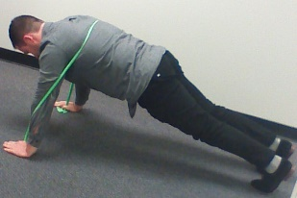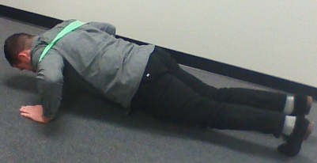

- Row
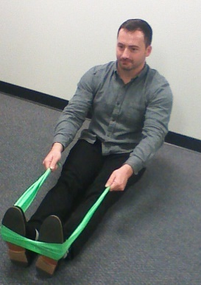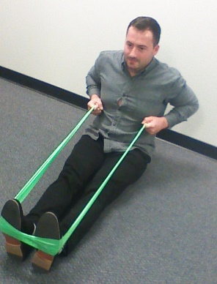
Coaching Cues:
- Maintain good posture;
  - Sitting straight up.
  - Back Straight.
  - Keep the “core tight”.
  - Don’t arch or round your back.
- Slow controlled movements.
- Breathe in while controlling the movement, breathe out while exerting force.
- Make a 90 degree angle during all movements, this is the full range of motion.
- Squat
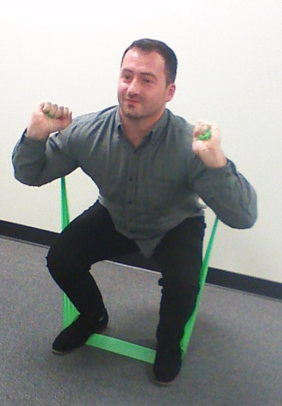
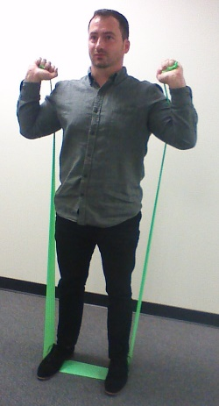

Do each exercise for 8-12 repetitions for 3 sets. Chain the exercises together to create a more cardio based workout!
Round 2-
- Overhead press
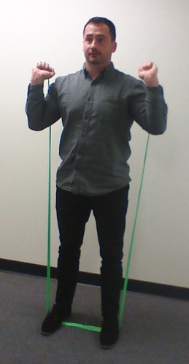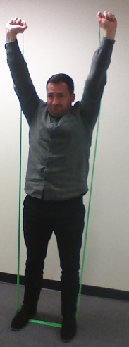 Can also do this exercise seated while sitting on the band.
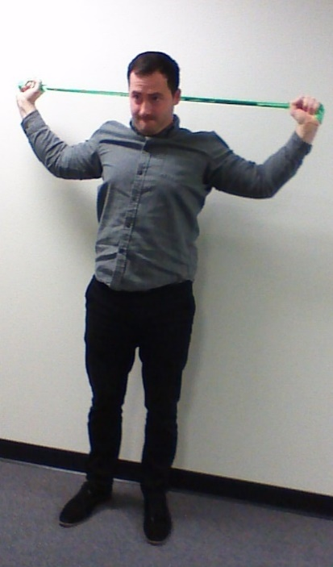
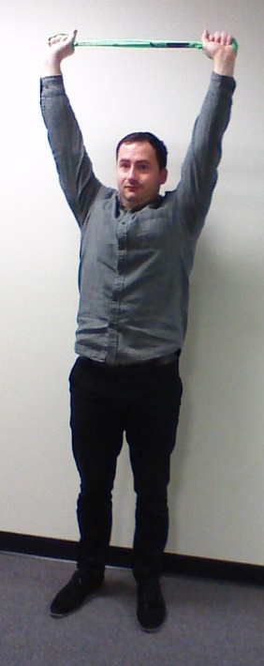
- Pull downs or Pull Apart (Lat and Bicep focused)
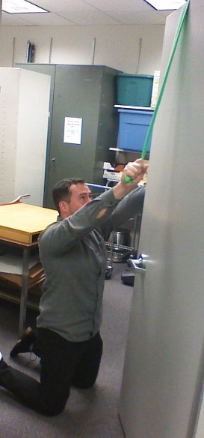
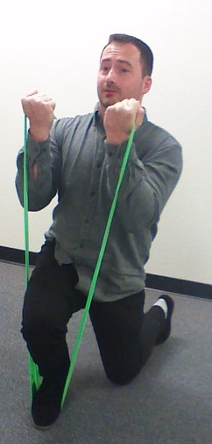
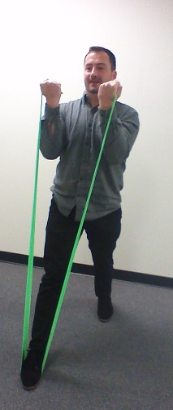
- Lunges

Do each exercise for 8-12 repetitions for 3 sets. Chain the exercises together to create a more cardio based workout!
Round 3-
- Bicep curl
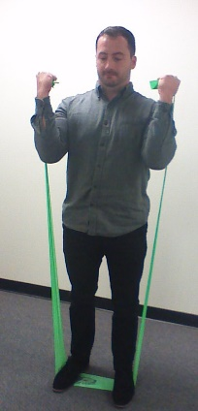
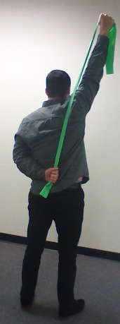
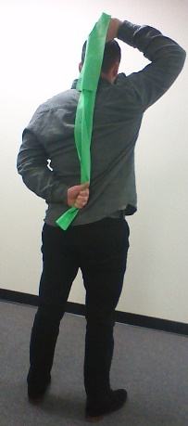
- Tricep extension

- Calf Raise



Do each exercise for 8-12 repetitions for 3 sets. Chain the exercises together to create a more cardio based workout!

Muscle Strengthening Exercises
- After completing the resistance band routine have participants take their pulse and then write down the average under anaerobic activity on the MyPulse board.
- Review talking points on page 6.8 of EHBA
- Inform participants they should breathe out when they are creating force during the exercise. They should breathe in as they control the movement or weight. Make sure you breath and do not hold your breath!
- Form is extremely important. Always maintain a stable spine position. Do not arch your back like a cat. Always use smooth and steady movements when exercising. Do not throw weights down or drop them. Be safe and cautious!
My Aerobic and Strengthening Activities Log
- Review the information on page 6.9 with the class.
- Explain to participants that proper planning is key.
- It can often be difficult to work exercise into our busy lives. There are many difficulties we must overcome to meet the two hours and 30 minutes a week, or 30 minutes a day for five days a week, of moderate aerobic physical activity as recommended by the Physical Activity Guidelines for Americans, not to mention the strength or resistance training we need to work in two times a week, and flexibility exercises two to three times a week. Perhaps the most common barrier that's hard to tackle is lack of time. In order to implement an exercise routine into our lives, many of us will need to plan out our day and see where we can fit exercise into our schedule.
- Not only does scheduling and planning our exercise help us find the time, it also helps us create a better structured and more concise work out program and makes us more likely to adhere to a well thought out plan, as opposed to exercising on an impromptu basis. By having a plan, you will likely hold yourself accountable because you set aside that time for your exercise. One important thing to remember is that our exercise doesn't have to take place all at one time. If you exercise for 10 minutes three times throughout your day, you will have met your 30 minute requirement for the day.

Example Exercise Program Plans
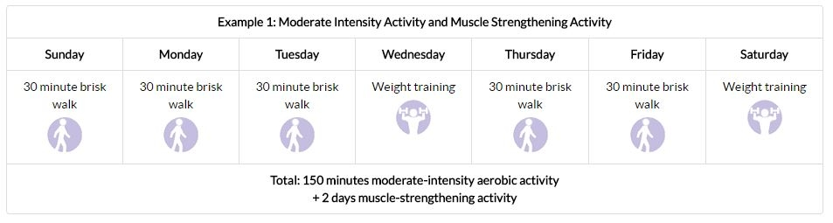
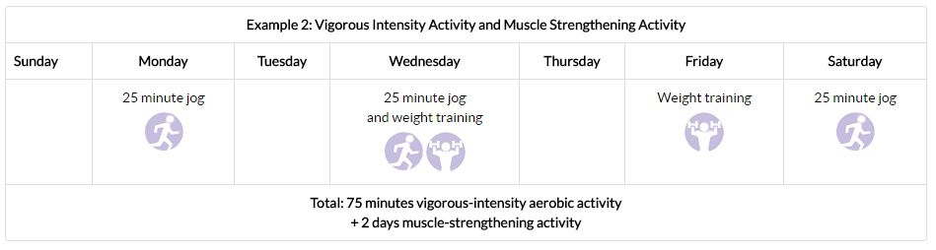
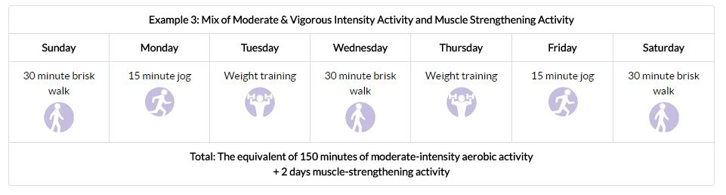

Session Wrap Up
- Provide a brief overview/ review of the information covered.
- Have the participants engage in 15-30 second static stretches.
  - Have the class practice deep and controlled breaths in and out.
  - After the class has stretched check their pulse and write down the average under cool-down.
  - Note how their heart rates went up and down depending on the activities.
- Provide the class with the following chart if they would like to reach a target heart rate.
Age | Target HR Zone 50-85% | Average Maximum Heart Rate, 100%
20 years | 100-170 beats per minute | 200 beats per minute
30 years | 95-162 beats per minute | 190 beats per minute
35 years | 93-157 beats per minute | 185 beats per minute
40 years | 90-153 beats per minute | 180 beats per minute
45 years | 88-149 beats per minute | 175 beats per minute
50 years | 85-145 beats per minute | 170 beats per minute
55 years | 83-140 beats per minute | 165 beats per minute
60 years | 80-136 beats per minute | 160 beats per minute
65 years | 78-132 beats per minute | 155 beats per minute
70 years | 75-128 beats per minute | 150 beats per minute
Table Source- http://www.heart.org/HEARTORG/HealthyLiving/PhysicalActivity/FitnessBasics/Target-Heart-Rates_UCM_434341_Article.jsp#.WKY4WlUrLIU

Lesson Enhancements
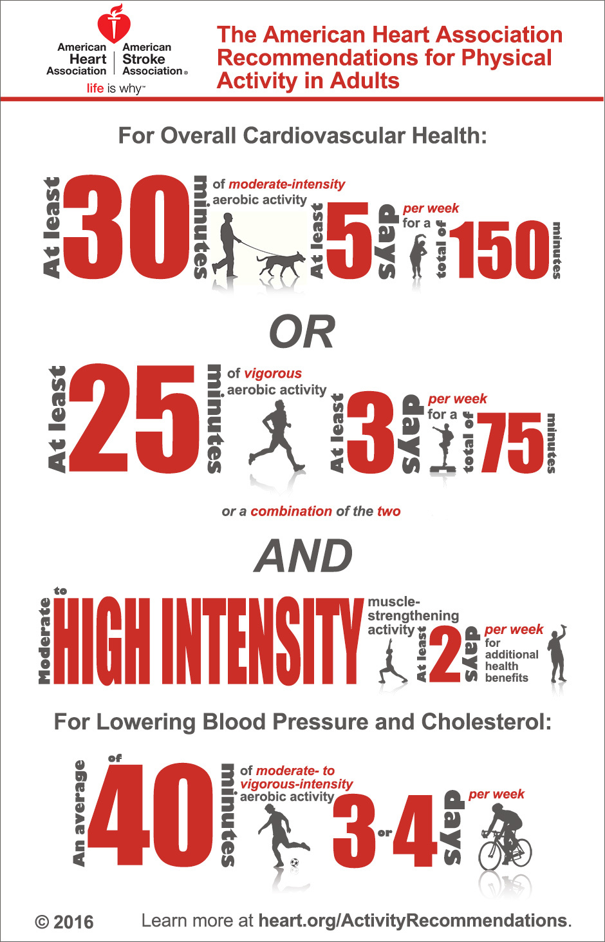

 | Approximate calories used (burned) by a 154-pound man
MODERATE physical activities: | In 1 hour | In 30 minutes
Hiking | 370 | 185
Light gardening/ yard work | 330 | 165
Dancing | 330 | 165
Golf (walking and carrying clubs) | 330 | 165
Bicycling (less than 10 mph) | 290 | 145
Walking (3.5 mph) | 280 | 140
Weight training (general light workout) | 220 | 110
Stretching | 180 | 90
VIGOROUS physical activities: | In 1 hour | In 30 minutes
Running/ jogging (5 mph) | 590 | 295
Bicycling (more than 10 mph) | 590 | 295
Swimming (slow freestyle laps) | 510 | 255
Aerobics | 480 | 240
Walking (4.5 mph) | 460 | 230
Heavy yard work (chopping wood) | 440 | 220
Weight lifting (vigorous effort) | 440 | 220
Basketball (vigorous) | 440 | 220

Source: https://www.choosemyplate.gov/physical-activity-calories-burn

Physical Activity Guidelines

Children and Adolescents (aged 6–17)
- Children and adolescents should do 1 hour (60 minutes) or more of physical activity every day.
- Most of the 1 hour or more a day should be either moderate- or vigorous-intensity aerobic physical activity.
- As part of their daily physical activity, children and adolescents should do vigorous-intensity activity on at least 3 days per week. They also should do muscle-strengthening and bone-strengthening activity on at least 3 days per week.

Adults (aged 18–64)
- Adults should do 2 hours and 30 minutes a week of moderate-intensity, or 1 hour and 15 minutes (75 minutes) a week of vigorous-intensity aerobic physical activity, or an equivalent combination of moderate- and vigorous-intensity aerobic physical activity. Aerobic activity should be performed in episodes of at least 10 minutes, preferably spread throughout the week.
- Additional health benefits are provided by increasing to 5 hours (300 minutes) a week of moderate-intensity aerobic physical activity, or 2 hours and 30 minutes a week of vigorous-intensity physical activity, or an equivalent combination of both.
- Adults should also do muscle-strengthening activities that involve all major muscle groups performed on 2 or more days per week.

Older Adults (aged 65 and older)
- Older adults should follow the adult guidelines. If this is not possible due to limiting chronic conditions, older adults should be as physically active as their abilities allow. They should avoid inactivity. Older adults should do exercises that maintain or improve balance if they are at risk of falling.
For all individuals, some activity is better than none. Physical activity is safe for almost everyone, and the health benefits of physical activity far outweigh the risks. People without diagnosed chronic conditions (such as diabetes, heart disease, or osteoarthritis) and who do not have symptoms (e.g., chest pain or pressure, dizziness, or joint pain) do not need to consult with a health care provider about physical activity.

Health Benefits of Physical Activity
Adults and Older Adults  Strong Evidence  - Lower risk of:  - -Early death  - -Heart disease  - -Stroke  - -Type 2 diabetes  - -High blood pressure  - -Adverse blood lipid profile  - -Metabolic syndrome  - -Colon and breast cancers  - -Prevention of weight gain  - -Weight loss when combined with diet  - -Improved cardiorespiratory and muscular fitness  - -Prevention of falls  - -Reduced depression  - -Better cognitive function (older adults)  Moderate to Strong Evidence  - -Better functional health (older adults)  - -Reduced abdominal obesity  Moderate Evidence  - -Weight maintenance after weight loss  - -Lower risk of hip fracture  - -Increased bone density  - -Improved sleep quality  - -Lower risk of lung and endometrial cancers | Children and Adolescents  Strong Evidence  - Improved cardiorespiratory endurance and muscular fitness  - Favorable body composition  - Improved bone health  - Improved cardiovascular and metabolic health biomarkers  Moderate Evidence  - Reduced symptoms of anxiety and depression

