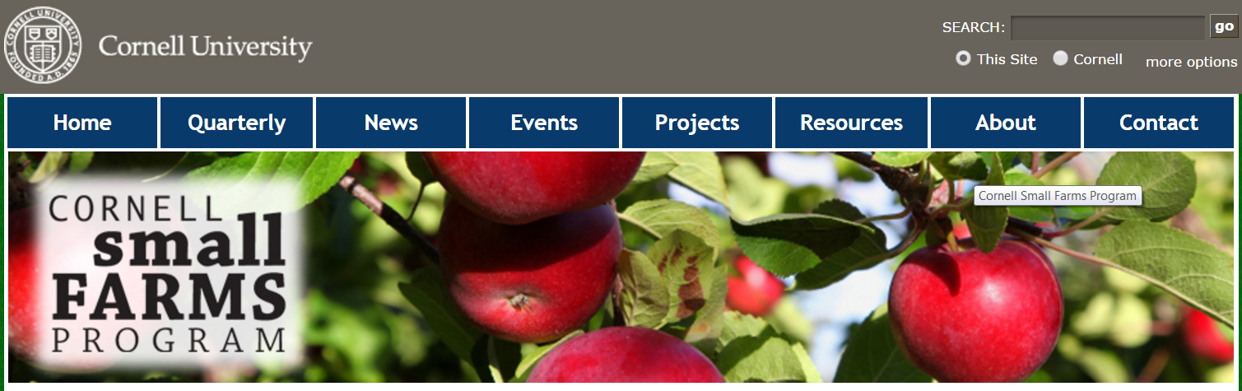

http://smallfarms.cornell.edu/2011/07/04/in-defense-of-specialization/

IN DEFENSE OF SPECIALIZATION
By Ulf Kintzel
The case has often been made that a diverse farm is less vulnerable if the market for one product, say pork, collapses. The other products produced on the farm will compensate for the lost income, so goes the theory. It is “hip” again to speak up for the diverse farm like we knew it from our grand-parents.
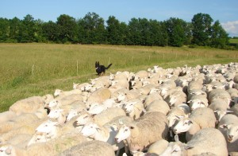
Raising sheep is all I do. Photo by Ulf Kintzel.
Why did farms specialize in the first place? Most arguably it is because of cost reduction. The more units are produced with the same machine, with the same management, with the same personnel, the less the cost per unit. This has brought us the 1,000 cow farm and the several thousand acre cash crop farm that grows corn and soy beans and nothing else. The argument is that these specialized farms bring environmental problems with them and are unsustainable. In addition, they are highly vulnerable to a collapse of the market for their specific product. The small diverse farm on the other hand is supposedly more sustainable, while writers and advocates imply that the mega farm is the most vulnerable to demise. Perhaps this is true, but why pick the extreme farm to make the case against specialization? Let’s compare apples to apples instead. Let’s compare a small specialized farm with a small diverse farm.
I raise sheep and that is basically all I do. While we raise some chickens, eggs, ducks, squabs, and many vegetables – all these products are for home consumption. The sheep and lambs I raise are basically the only commercial product. So, I am indeed highly specialized. I am also considered a small farm. I farm about 130 acres of pasture. I buy all my hay. Together with my wife’s off-farm income we make a comfortable living.
Specialization allowed me to get a special set of knowledge about sheep and about pasture. While it is impossible to know everything, I am confident that my knowledge has a lot of depth. Few sheep diseases or unforeseen events surprise me or put a dent into the profitability of my enterprise. I am convinced that such knowledge with such depth cannot be compiled when focusing on many different species and crops. The saying “Jack of all trades, master of none” had its origin somewhere. The special knowledge I have gained helps me raise my profit margin since I profit far more per ewe than the average sheep farmer.
Specialization also always means cost reduction. You have the same fixed costs whether you raise 50 sheep or 100. Cost reduction through specialization is a well established and undisputed fact. Thus, I will refrain from elaborating more on this detail.
Furthermore, the specialized farm creates peaks in labor but it also gives you down time. In my case, the most notable peaks in labor are my three lambing seasons and later marketing the meat. But I also have enough down time that I can go once a year for a week on vacation, leaving the remaining work to a hired hand. How many farmers can easily do that? A customer of mine who bought breeding stock from me farms far less land than I do but has far more animal species and in addition grows produce. He is as diversified as one can possibly be. He complained that he has no off time whatsoever. When lambing is over, chickens need to be butchered. When that is done, vegetables need to be harvested. The list continues and he admitted it wears him out.
What about the claim that specialized farms are vulnerable to a collapsing market? The answer is simple. Diversify your market. The traditional market is the finished market lamb. The claim has been made on occasion that one has to have a market first, then one can or should produce a product. I disagree. Markets can be created, at least to a degree. Does the reader believe there was a market for “Facebook” or the TV show “The Apprentice”? I doubt there was. I am convinced marketing created these markets. That can be done with your product as well. In the case of my sheep I entered the market for breeding ewes of a hairsheep breed. While I certainly have buyers who all along wanted hairsheep, I have far more buyers who bought that hair sheep ram for their flock because it is now easily and affordably available. I furthermore diverse my market by selling freezer lambs off the farm or via a buying club in New Jersey. These are perhaps 80 or more customers. There is just no conceivable market collapse that can much impact a customer base which is not at all ethically uniform and extremely diverse instead. I also sell lambs to another organic farmer who is good in raising pigs and beef but needed a supplier of excellent grass-fed lamb. I am also selling to two distributors – one small and local and one large. Last but not least, did I mention that I train herding dogs and give sheep herding lessons as well?
The products offered from a single species can be rather diverse. In case of a sheep it can be wool products, freezer lamb, sheep sausage, individual cuts versus half or whole lambs, burgers and the list goes on. One can also entertain the thought to buy additional products from other farmers like pork, beef, eggs, chickens, and honey as my neighboring sheep farmer does. It is a win-win scenario for both him and the producers. He attracts customers and the producer has a market for what he or she does best: producing his or her specialized product.
The specialized farm also gives me the time to do the marketing necessary in order to add value to my product instead of selling it as a commodity product. How many farmers have you heard saying “I got no time for that” when asked about marketing their product. They simply have too much work and can’t focus on marketing. If you want to satisfy one hundred customers each year that want to buy half a freezer lamb, or a ram lamb, or five breeding ewes, you will need to be able to take that time. A specialized small farm will give you that time.
If you raise a variety of products, market to a broad customer base, and still run into financial trouble, perhaps you have larger problems that even a diverse farm would not save you from. If you are managing the farm well, the collapse of one market should not have a devastating effect on your whole enterprise.
Specializing your production does not mean that one should not grow a few other crops or raise a few other animals to complement your main production, i.e. raising a few pigs on whey that would otherwise go to waste when you make cheese. It also does not mean you should not have a few side projects that your kids will do as chores like feeding a few rabbits or chickens to learn to be responsible and productive. And it certainly does not mean you shouldn’t raise whatever food you want to raise for your family and perhaps friends. We certainly do that. It does mean, however, that the focus should be on one specific way of raising animals or growing crops instead of having several production venues at once that all carry the same weight and have the same importance. And don’t kid yourself about the nature of your farm. If three-quarters or more of your income comes from one or two products, you are a specialized farm no matter how many side projects you entertain.
In summary, running a specialized farm has in my opinion more advantages than disadvantages: cost reduction, in depth knowledge, and peaks but also down times in labor. These down times in labor can be used to take care of your customers, to recover from labor peaks, or perhaps to go on vacation. To reduce the vulnerability of such farm to market swings and possible collapses, one should try to diversify the market as much as possible. If one feels the need to have some diversification in production to escape boredom and wants to make it interesting, one can always raise some poultry, beef or pork or grow some vegetables and fruit for home consumption. That might be just enough diversification to satisfy you without burdening you with a lot of labor and cost.
Ulf Kintzel owns and manages White Clover Sheep Farm (www.whitecloversheepfarm.com) in Rushville, NY where he breeds grass-fed White Dorper sheep. He offers breeding stock and freezer lambs. He can be reached at 585-554-3313 or by e-mail at ulf@whitecloversheepfarm.com.
Copyright 2010 Ulf Kintzel. For permission to use either text or photographs please contact the author at ulf@whitecloversheepfarm.com.

