UC Master Food Preserver Program of San Luis Obispo/Santa Barbara County
Food Bank Outreach Project
Objectives

- Increase MFP exposure in communities
- Ideas of new ways to use produce as well as extend shelf life
- Increase awareness of Food Safety

The reinforcements and handouts are coordinated whenever possible to what produce is handed out at the various sites.

Local Food Bank

- Get to know your partners, tour the facility if possible. Develop working relationships. There may be a different contact at each site, names and faces are important. (Example: there is a different contact here in SLO County at school sites. They still coordinate with the SLO Food Bank.) At some sites there are other Volunteers handing out produce as individuals as well as groups as Rotary, Lions, Church members, etc.
- Use the Food Bank calendar to post volunteer opportunities into the VMS calendar one month out or more. Note any special instructions per site on each opportunity post as needed.
- Check in with coordinator a week prior to get a sense of what produce is being handed out AND average number of vehicles coming thru to coordinate a specific handout and quantity of reinforcements.

NOTE:
- SLO/SB VMS has a special "category" for Food Bank for tracking hours for reports.
- Remind MFP volunteers that time driving to /from site, picking up supplies counts as well as distribution counts as volunteer hours.

Posting Food Bank Opportunities on VMS

- Post date, time, and location of site
- Note the "Limit number of volunteers" at site, make note of no guests
- Mark the box so that Food Bank coordinator is notified via email
- Send a reminder email the day before or day of to follow up on health check and let MFP coordinator know that you're clear
- Food Bank Coordinator emails MFPs that opportunities are posted on VMS for the next month

Reinforcements

- Money availability from $$ Donor Fund, Class fees, Fund raisers (ie. giving Tuesday, Big Dig (post photos from Food Bank work during these events)
- Literature handouts from UCANR, Cal Fresh, Simple recipes in both English/Spanish
- Supplies from Dollar Tree, 99¢ stores, catalogs
- Plan by season (ie. Harvest Apple season)

Past Reinforcements
- Apple Slicer/Corers -Applesauce Recipe, Caramel Dipping Sauce
- Mini Citrus Reamers
- Ice Trays-Lemonade recipe, Pesto or Flavored butter recipes
- Veggie Brushes-Food Safety Handout
- Refrigerator/Freezer Thermometer-Food Safety
- Freezer Bags-Applesauce Recipe or Soup recipe
- Pickle Kits
- Freezer Jam Kits

Future ideas
- Popsicle trays-Recipes
- Washable cutting mats-Food Safety
- Colander-Food Safety, washing produce
- Laminated charts, Emergency Kit, misc

Drive-thru (vs Tabling pre-Covid)

- Set up at site, coordinate with other Lead volunteer and share
- Apron/Badge/Mask
- Standing or walking for 1-2 hours (bags, basket or bucket)
- Take pictures of set up, items, and action shots for FB/IG
- Less than 30 seconds to engage with client
- Bag reinforcement with handouts
- Food Bank office on wheels (supplies)
- Inventory items left over to get a head count

Follow-up
- Coordinator emails volunteers to thank and remind them to post hours in VMS.
- Post pictures on Social Media platforms
- Pick up supplies from volunteer
- Track reinforcements handed out by site on spreadsheet
- Plan and order for next event

Handouts and Reinforcements
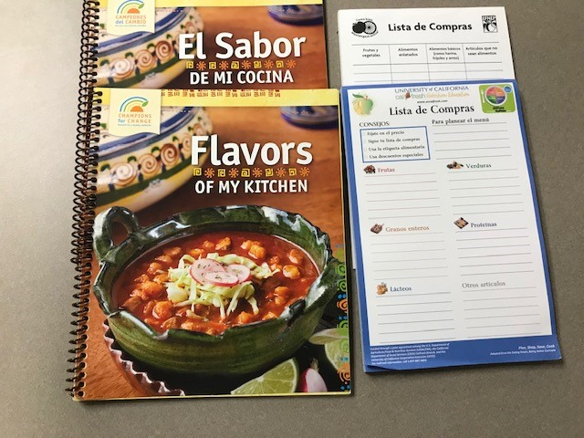 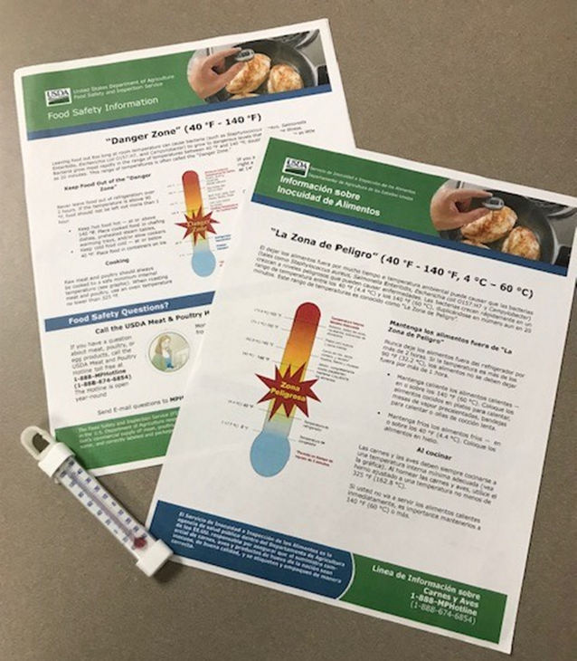
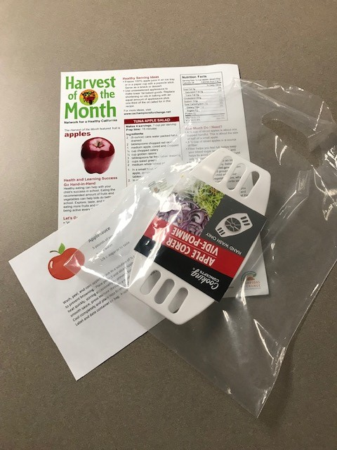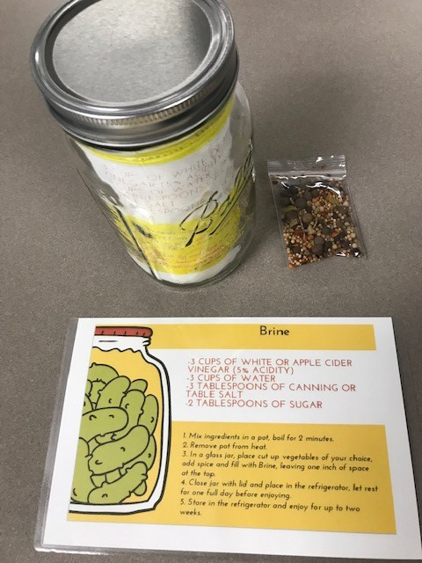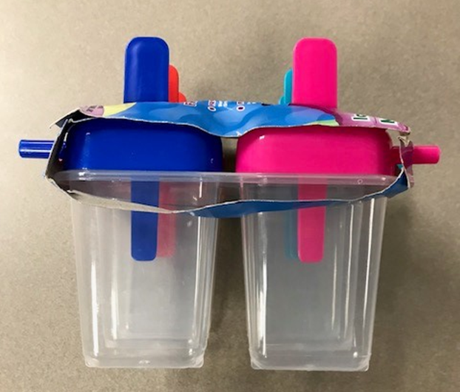
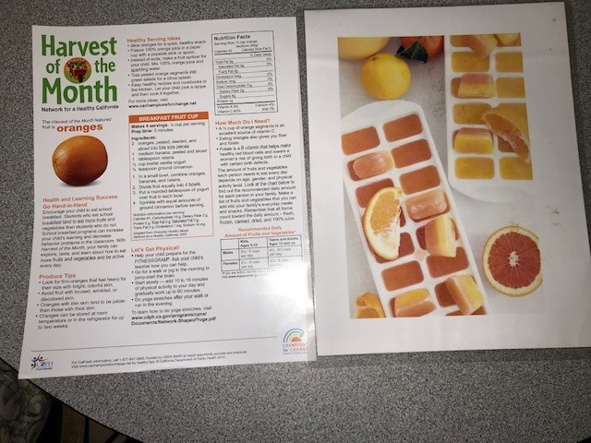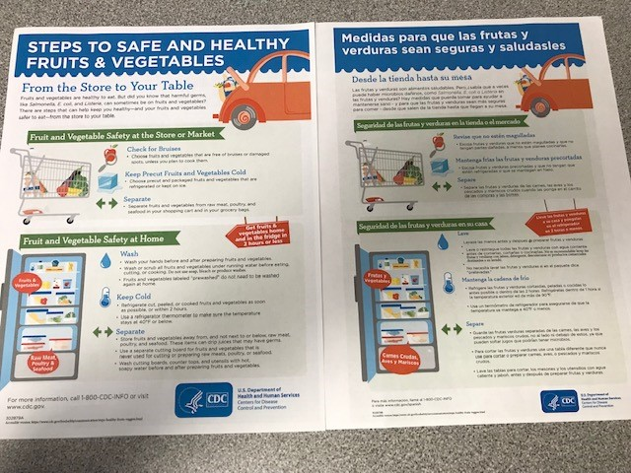
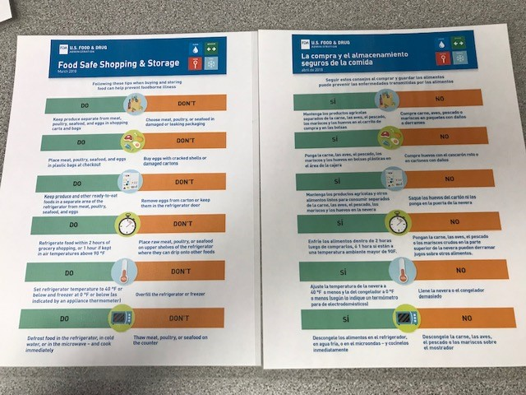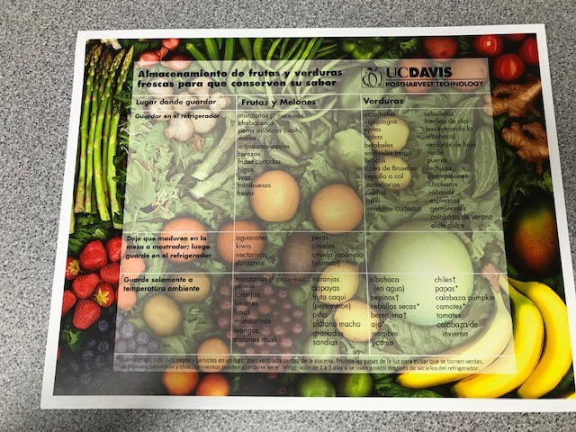
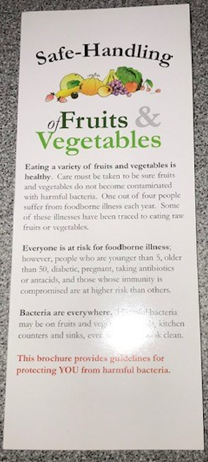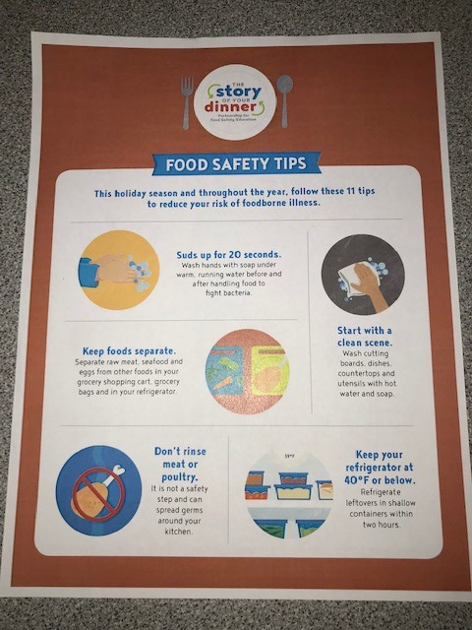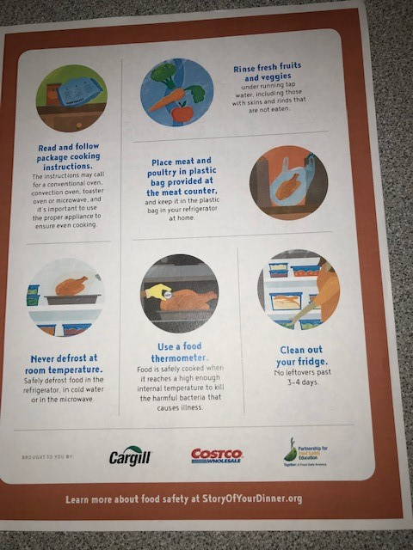
 die cut handle clear plastic bags
Ideas from brain storm session for Food Bank Distribution of food safety ideas, etc plus reinforcements:

Food safety/Hand Washing/Kitchen Prep Areas (seen at Dollar Tree)
-Anti-bac soap (with pump) with Safe Hand Washing Handout
-Bleach Safe Spray Bottle with Sanitizing Recipe Card
-Washable Silicone cutting boards for meat, veggies with Handout

Produce
-Silicone Scrubbies for produce washing with How to wash produce handout (something different than veggie Brushes)
-Colander with above handout
Possible other topic handouts not necessarily with a reinforcement, maybe some sort of laminated printout especially for Food/Water safety during outages.
-Emergency Prep
-Food/Water Safety during Power Outages
-Food Safety in the Garden
-Potluck Paranoia-Food safety tips
-Lunch box/Brown bag Food Safety
-Food dating/Pantry Safety
-Burn Safety (from cooking)
-Poison Safety

