Central Valley Milk and Management Notes
Issue 1 - 2026
Fresno, Madera & Kings

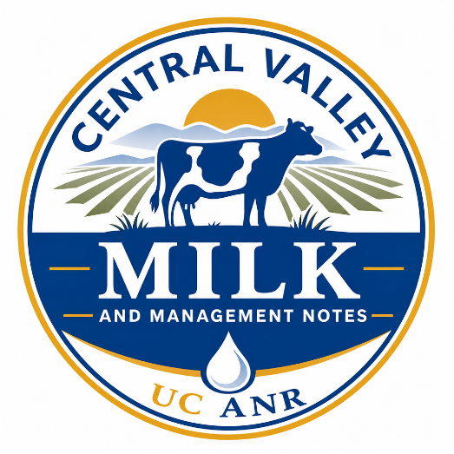
The Bugs That Cost You Milk: What 14 Years of Data Reveal

Daniela Bruno, UCCE Fresno, Madera & Kings Counties

Every cow tells a story when she walks into the parlor. Some stories are simple: clean milk, no swelling, and a smooth milking time. Others start with clots, watery milk, or a swollen quarter. Behind every case is a microorganism that found its way into the udder. Mastitis isn’t just a health issue; it’s a daily drain on milk, labor, and cow comfort, and it remains one of the most costly and frustrating challenges for dairies.
Back to the basics
What is mastitis?
Mastitis is not an infection. It’s an inflammation of the mammary gland, almost always caused by bacteria.
Where do these microorganisms come from?
Environmental microorganisms live in the cow’s environment (bedding, manure, alleys, water, towels, hands) and enter the udder when cows lie down on dirty beds, when teat ends stay open after milking, or when milking hygiene slips.
Contagious microorganisms live in cows’ glands and spread cow-to-cow during milking through hands, towels, liners, or milk droplets.
What the 14-Year Study Found
A new long-term study from the University of California analyzed more than 310,000 milk samples submitted for routine culture between 2009 and 2023, providing the clearest picture yet of which bacteria are causing mastitis in the San Joaquin Valley and how those patterns shift with season.
Across all years, environmental bacteria were far more common than contagious ones. About 27% of samples showed no bacterial growth, while contamination occurred in about 6%. Of the samples with growth but not contaminated, 95% were environmental, while only 5% were contagious pathogens (Fig.1).

Understanding “No Growth” and Contamination
No growth results can occur when the cow cleared the infection before sampling; bacteria aren’t being shed at the moment; the bacterial load was too low to detect; or antimicrobial treatment occurred before sampling.
Contamination can come from manure, feed, bedding, air, teat skin, and the teat canal. When the sampling technique isn’t fully aseptic. Good sampling techniques, such as clean teats, sterile tubes, and careful handling, can reduce contamination and improve culture accuracy.
Most common environmental bacteria
The most common environmental bacteria were non-aureus Staphylococci, Coliforms (E. coli, Klebsiella, Enterobacter), and Environmental Strep (S. uberis, S. dysgalactiae). Among contagious pathogens, Staphylococcus aureus was the most common, followed by Mycoplasma and Streptococcus agalactiae (Fig. 2). This low prevalence of contagious pathogens in relation to the environment reflects strong milking-time hygiene and control programs on many dairies.

Seasonal Differences
- Winter: highest isolation of most pathogens and highest contamination, likely due to this season being wet and muddy
- Summer: highest isolation of non-aureus Staphylococcus and highest rate of no-growth, likely due to heat and dry conditions

What does this mean for your dairy?
By providing a 14-year perspective on bovine milk microbiology, the study supports dairy producers, veterinarians, and researchers in optimizing herd health and refining disease prevention approaches tailored to regional conditions. Understanding the prevalence and distribution of mastitis-causing bacteria is crucial for controlling and preventing bovine mastitis.

Mastitis Control Plan

- Set herd udder health goals: define realistic targets for SCC and clinical mastitis. Review progress and adjust as needed
- Track outcomes: use data to monitor mastitis, milk quality parameters, and trends of pathogens
- Monitor subclinical mastitis: use cow-level SCC testing to detect cases early and record them consistently
- Identify microorganisms causing mastitis to guide treatment and management
- Keep the environment clean: maintain dry, comfortable stalls, manage recycled manure bedding, control moisture and organic matter buildup, improve ventilation, and reduce environmental stressors like heat, insects, and stray voltage.
- Strengthen milking hygiene: check foremilk, pre-dip for ≥30 seconds, dry teats with clean towels, wear gloves, attach cups within 90 seconds of prep, remove clusters promptly and post-dip, and milk contagious cows last
- Maintain milking equipment: Service equipment regularly, replace worn parts, and sanitize before and after each milking to maintain proper vacuum and pulsation.
Take-Home Message
Seasonal changes, herd management, and herd dynamics all influence the prevalence of mastitis-causing pathogens. Whether you manage 500 or 5,000 cows, tracking pathogen trends through regular herd health checks and milk cultures, along with consistent record-keeping, empowers smarter decisions and protects udder health year-round. These insights help you build a mastitis management plan tailored to your operation. If you’d like help interpreting your herd’s culture results or building a mastitis plan, reach out.

Daniela Bruno, DVM, PhD
dfbruno@ucanr.edu
559-241-7552

The University of California prohibits discrimination or harassment of any person in any of its programs or activities. (Complete nondiscrimination policy statement can be found at http://ucanr.org/sites/anrstaff/files/107734.doc)
Inquiries regarding the University’s equal employment opportunity policies may be directed to Affirmative Action Contact and Title IX Officer, University of California, Agriculture and Natural Resources, 2801 2nd Street, Davis, CA 95618, (530) 750-1397; titleixdiscrimination@ucanr.edu.

