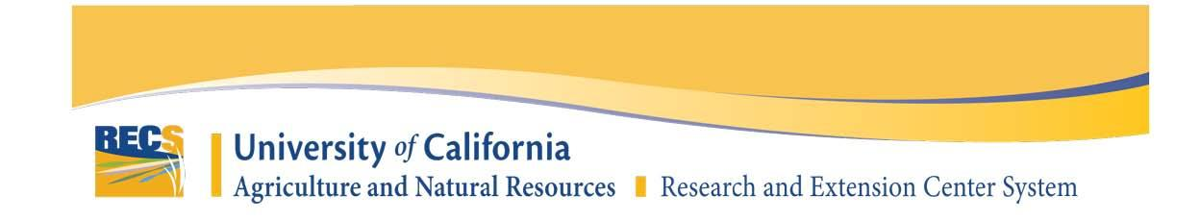

**NEW PROJECT PROPOSAL FORM**

Project Title:

Project Leader & Affiliation:

Project Cooperators & Affiliation:

**Provide detailed narratives addressing each of the following items (2-4 pages total):**

ABSTRACT:

**1. Justification:** Describe the problem and the importance of the proposed research for agriculture or natural resources. What impact will this research have on crop production, economics, or the environment? What regions of the state will it affect? Explain why the project needs to be conducted at this Center.

**2. Previous Work:** What previous work has been done in this area by yourself and others? What preliminary data, if any, indicate that the proposed research will accomplish the stated objectives?  ***(Note: if you have filling this form as part of your 3 Year Progress & Research Results, it is not necessary to answer this questions*)** (Maximum 2 pages)

**3. Objectives:** List the specific objectives or hypotheses of the proposed work. Number your objectives and limit them to one sentence each.

4. **Procedures:** For eachobjective, discuss the experimental procedures you propose to use. Include the experimental design (size and number of plot areas, number of treatments, number of replicates etc), data to be collected, and methods of data analysis.

**5.** **Extension of Results:** Explain plans for sharing research results including publications, field days, seminars, websites, etc. When will these research results be available for use by clientele? Who in Cooperative Extension will be involved in demonstrating the results and what is their involvement?

**6.** **Timetable:** What is the expected duration of the project? Will the project expand in scope? Provide an estimated timeline for the various phases of the project.

**7.** **Expected Outcomes and Benefits:**