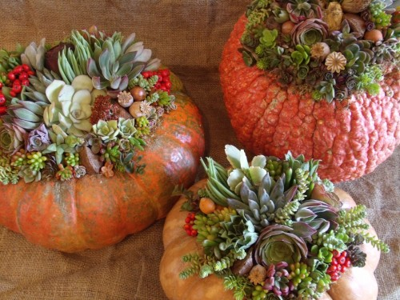
SUCCULENT PUMPKINS

Have you ever thought of tantalizing your succulent whimsy? With Halloween and Thanksgiving just around the corner, I think you might like this craft. If you enjoy creating succulent containers, you’ll enjoy making this succulent pumpkin.

Materials:
- Clean 8-12 “ pumpkin with a concave top, remove stem( the more unusual the better)
- Sphagnum moss
- Spray adhesive
- Clear gel glue-hot glue gun
- Woody seedpods, acorns, rosehips, nuts in shells
- Few clusters of red berries, pyracantha, red pepper, cottoneaster
- Assortment of small, colorful succulents
- Scissors
Succulents: Aeoniums, crassula, echeveria, graptosedum, haworthia, kalanchoe, assorted sedums
Directions:
- Coat the pumpkins bowl shape top with spray glue.
- Press dry moss onto the glue to form a ½’ thick bed.
- Using the hot glue gun, glue the bottoms of the succulent
rosettes atop the moss, beginning with the largest succulents, a
little off center and adding smaller ones as you work outward.
- Intermingle with the other dried berries, nuts, cones and acorns.
- Surround the center rosettes with smaller succulents like sedums.
- As you add more cuttings, and dry items, aim for balance and variety.
- You want to have an abundant look with no moss showing. Plus, an
eclectic mixture of colors and textures.
- Using scissors trim the excess moss.

Once or twice a week, spritz the arrangement with water to refresh the leaves and moss. Do not let water pool in the top of the pumpkin. A cool, dry location is best. If you leave it outside, place it on a trivet, not on concrete, where air can circulate. Protect the pumpkin from frost. To salvage the succulents, take cuttings. Or, just set the pumpkin in the garden, You can even slice the top off and plant it.



