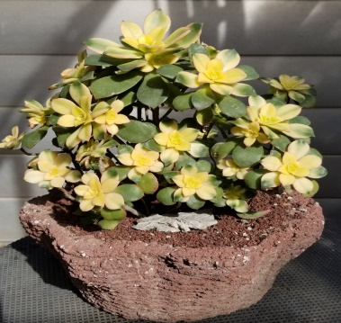
Steps to make Hypertufa
Materials Needed
- Dust mask
- Gloves
- Mixing tub and container for measuring
- Cement colorant
- Hand Trowel
- Spray oil
- Plastic bags
- Molds or baskets
- PVC to make hole in tufa
Get Started
- Gather raw materials – Perlite, Peat Moss, Portland Cement
- Recipe Ratio – 1 ½: 1 ½: 1
- Mix Perlite and Cement until one color; add Peat and mix thoroughly
- Slowly add water in small amounts until consistency looks correct (like cottage cheese)
- If adding color to cement – mix with water first
- Mix thoroughly until water is absorbed and tufa can hold together when squeezed – if material is too wet let it sit to absorb excess
- Mold should be prepped with spray oil and lined with plastic. If using a basket, just spray with oil. Do not line with plastic bag.
- Add tufa to bottom of mold to a depth of 1” approximate – on larger pots make thicker walls
- Start to build the sides with same thickness
- Push the tufa into the corners/ends to distribute evenly
- Use a dowel to make drain holes
- When finished, use another bag to cover completely
- After 24-48 hours remove plastic and mold.
- Use wire brush and tools to clean up or make design
- Re-wrap the pot and let it cure in the shade 2 -3 days minimum (longer in winter)
- Check on the pot every few days to make sure there is moisture
- After curing in the shade, remove plastic and leave the pot in the sun. Sprinkle with water every few days to continue the cure, or soak in water to remove any chemical residue from the cement
- Now, your tufa is ready to plant
Tips/Do’s & Don’ts
- Have all materials out and ready
- Spray the mold and plastic bag well
- Remove dowel after making holes
- Make sure printing is on the inside of the plastic bags, not touching the tufa
- Be careful of too thick or thin walls
- Don't use wired baskets. Too hard to remove mold.

