Free Gardening and Preservation Workshops
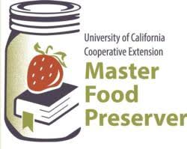
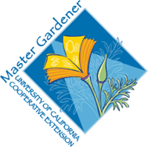
Saturday, Jan 22, 2022
Chino Hills Branch Library
14020 City Center Dr,
Chino Hills, CA 91709

Growing and Preserving Home-Growing Fruit Trees and Preserving your Harvest
(9:00am-12:00pm)
Sustainable Landscaping
(1:00pm-2:00 pm)

Managing Pests in the Garden
(2:00pm-3:00 pm)

Come to one or join us for the day!
Registration is not required, but registered attendees will receive a copy of printed resources and other items:
https://surveys.ucanr.edu/survey.cfm?surveynumber=36070
