Free Gardening and Preservation Workshops
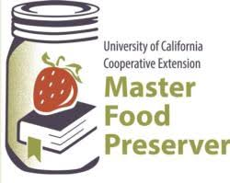
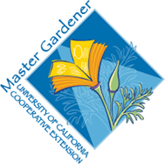
Saturday, Feb 26, 2022
Fontana Lewis Library
8437 Sierra Ave,
Fontana, CA 92335

Growing and Preserving Home-Growing & Preserving Warm Season Fruits and Vegetables
(10:00am-1:00pm)
Sustainable Landscaping
(2:00pm-3:00 pm)

Managing Pests in the Garden
(3:00pm-4:00 pm)

Come to one or join us for the day!
Registration is not required, but registered attendees will receive a copy of printed resources and other items:
https://surveys.ucanr.edu/survey.cfm?surveynumber=36071
