Join the UCCE San Bernadino County Master Gardeners and Master Food Preservers

*at the*

**Hesperia Branch Library**

**9650 Seventh Ave, Hesperia, CA 92345**

**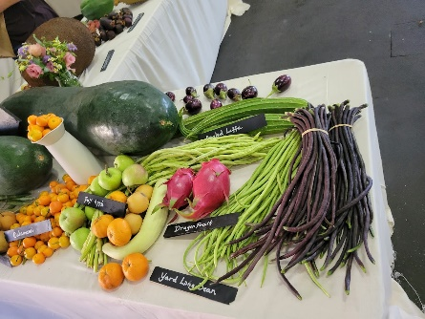***From*

**10 to 4pm**

**April 6th, 202**

**10 to 11:30am**

Cool Season Veggie Gardening

Soil care demo

Seed saving & Starting Tips

**11:30 to 1pm**

Home Food Preservation

**2 to 4pm**

Stop by our Ask a Master Gardener & Master Food Preserver Table for free seeds and to ask all your gardening and food preservation questions!

For more information email: [magoneill@ucanr.edu](mailto:magoneill@ucanr.edu)Or go to our website: <http://mgsb.ucanr.edu/>