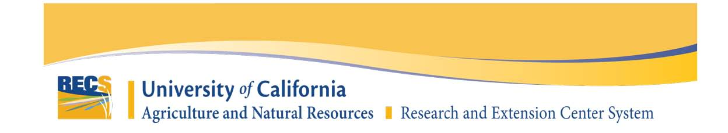
NEW PROJECT PROPOSAL FORM
EXTENSION ONLY

Project Title:
Proposed Research Location (REC Location):
Project Lead Name:
Affiliation:
(AES, CE Specialist, CE Advisor, UC Affiliated, USDA, Non-UC Institution, Other)
Location:
(UC Campus, UC ANR Location, Address for Non-UC, County)
Email:
Phone (optional):

AES Project Number (if applicable):
Is this a Federally Funded Project? Yes☐ No☐

Project Cooperator(s):
Fill out the name, role, affiliation, and location for each project cooperator (separate each cooperator with a comma or a paragraph):

Billing Contact (name, email, phone):

Estimated Start Date:

- Justification:
  - Broadly describe the proposed extension project and its alignment with agriculture and natural resources.
  - How would this extension activity benefit and/or impact the knowledge base of the targeted clientele?
  - Explain why the project is ideally suited to be conducted at this Center.

- Previous Extension Work:
  - What previous extension work has been done in this area by yourself and other colleagues?

- Objectives:
  - List the specific objectives of the proposed extension activity. Number your objectives and limit them to one sentence each.

- Procedures:
  - Describe the overall extension activity procedures (field day, workshops, demonstrations, tours, etc.) that you propose to take place at the center. Include the program design (frequency, expected number of attendees, size of demonstration plot, etc).
  - Who in Cooperative Extension will be involved in the extension activity and what is their involvement?

- Timetable:
  - What is the expected duration of the project?
  - Will the project expand in scope?
  - If a phased project, provide an estimated timeline for the various phases, including any expansion of the scope.

- Public Values:
- Which of UC ANR’s public values does this research project most closely align to? (max 2)
https://ucanr.edu/sites/anrstaff/Divisionwide_Planning/UC_ANR_Public_Values/
☐ Promoting economic prosperity in California
☐ Developing a qualified workforce for California
☐ Safeguarding abundant and healthy food for all Californians
☐ Protecting California’s natural resources
☐ Building climate-resilient communities and ecosystems
☐ Promoting healthy people and communities
☐ Developing an inclusive and equitable society

- Documents:
  - Upload any documents that would provide additional support to your proposal.

