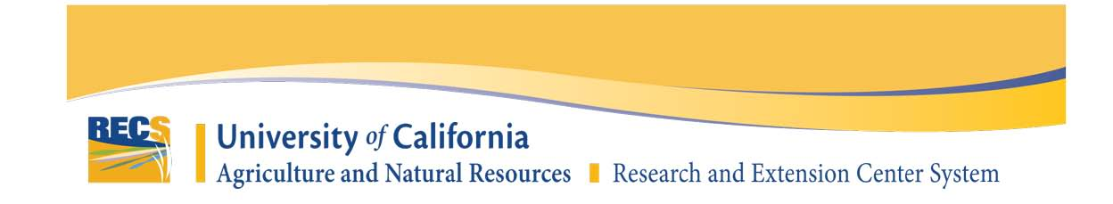
NEW PROJECT PROPOSAL FORM

Project Title:
Proposed Research Location (REC Location):
Project Lead Name:
Affiliation:
(AES, CE Specialist, CE Advisor, UC Affiliated, USDA, Non-UC Institution, Other)
Location:
(UC Campus, UC ANR Location, Address for Non-UC, County)
Email:
Phone (optional):

AES Project Number (if applicable):
Is this a Federally Funded Project? Yes☐ No☐

Project Cooperator(s):
Fill out the name, role, affiliation, and location for each project cooperator (separate each cooperator with a comma or a paragraph):

Billing Contact (name, email, phone):

Estimated Start Date:

- Justification (Abstract):
  - Describe the problem and the importance of the proposed research for agriculture or natural resources.
  - How will this research benefit California agriculture, natural resources, or the California population (expected outcomes and benefits)?
  - Explain why the project is ideally suited to be conducted at this Center.

- Previous Work:
  - What previous work has been done in this area by yourself and other colleagues?

- Objectives:
  - List the specific objectives or hypotheses of the proposed work. Number your objectives and limit them to one sentence each.
  - What preliminary data, if any, indicate that the proposed research will accomplish the stated objectives?

- Procedures:
  - For each objective, discuss the experimental procedures you propose to use. Include the experimental design (size and number of plot areas, number of treatments, number of replicates, etc.), data to be collected, and methods of data analysis.
  - Please include any information on acreage needs, greenhouse space, cooler and laboratory requirements, use of livestock/animals, etc.

- Extension of Results:
  - Explain plans for sharing research results including publications, demo days, field days, seminars, websites, etc.
  - When will these research results be available for use by end user?
  - Will Cooperative Extension (CE) be involved in demonstrating the results, and if so, who in CE will be involved and in what manner?

- Timetable:
  - What is the expected duration of the project?
  - Will the project expand in scope?
  - Provide an estimated timeline for the various phases of the project, including any expansion of the scope.

- Public Values:
  - Which of UC ANR’s public values does this research project most closely align to? (max 2)
https://ucanr.edu/sites/anrstaff/Divisionwide_Planning/UC_ANR_Public_Values/
☐ Promoting economic prosperity in California
☐ Developing a qualified workforce for California
☐ Safeguarding abundant and healthy food for all Californians
☐ Protecting California’s natural resources
☐ Building climate-resilient communities and ecosystems
☐ Promoting healthy people and communities
☐ Developing an inclusive and equitable society

- Documents:
  - Upload any documents that would provide additional support to your proposal (upload these documents on the online form).

