|  |  |
| --- | --- |
|  | Agricultural Labor Management Programs  Sponsorship Form |

The UC Cooperative Extension, San Diego is organizing an **Ag Labor Management Education Program** to help agricultural employers mitigate labor related risks. Labor related issues are becoming a major threat for Agricultural businesses across California, regardless of size or number of employees. Each year brings new laws and regulatory requirements for ag employers and each new requirement creates potential for fines, lawsuits, and additional confusion for employers and field supervisors tasked with implementation. Ag employers and their supervisory staff must remain informed of these requirements to protect workers, their operations and their assets.

The **Ag Labor Management Education Program** will help agricultural employers, HR managers and their field supervisors to better understand and comply with numerous requirements using a two-tier approach that includes a series of seminars and workshops as described below:

* **Ag Employer Seminars**: Three seminars will be offered in English by labor experts including attorneys and enforcement agency representatives to provide updates and guidance on key issues impacting agricultural labor. Topics include wage and hour; union card-check elections; new worker health and safety requirements; paid leaves of absence; requirements and best practices for H2A Visa workers, and a range of other potential issues and liabilities.
* **Ag Labor Supervisor Workshops**: Five training workshops will be offered in Spanish by highly experienced bilingual instructors to help supervisors learn about their critical roles and how to better manage and communicate with employers and workers. Supervisors will learn to implement required policies and procedures to foster employee retention and more effectively prevent and manage work injuries, harassment claims, union interventions, and wage and hour issues.

We invite you to be a part of this effort and sponsor this valuable education program to help ag businesses across California comply with labor laws and regulations. Your financial support will help provide these programs at a minimum cost to participants and allow us to offer them in additional locations across the state. Sponsorships levels and the dates and locations for this seminar and workshop series are detailed below:

**Seminar and Workshop Dates/Locations**

|  |  |
| --- | --- |
| ***Ag Employer Seminars:***   * Farm Bureau, Escondido - August 14, 2024 * Santa Maria Inn, Santa Maria - February 2025 * Harris Ranch, Coalinga - March 2025 | ***Ag Labor Supervisor Workshops:***   * Farm Bureau, Escondido – August 15, 2024 * Santa Maria Inn, Santa Maria February 2025 * Palm Desert/Coachella – February 2025 * Holtville- February 2025 * Harris Ranch, Coalinga – March 2025 |

For questions, please contact Darlene Ruiz at [druiz@ucanr.edu](mailto:druiz@ucanr.edu)

*\*Your sponsorship is tax-deductible, and our office will send proper documentation to you after we receive and process your contribution.*

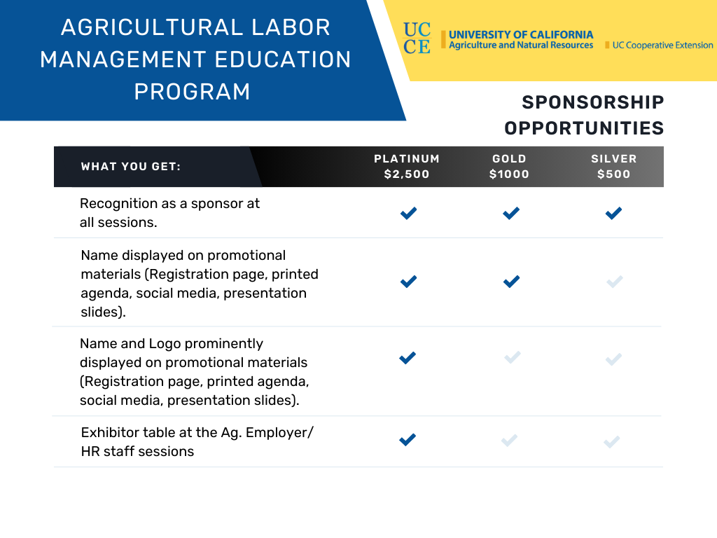

**YES! I would like to become a** *(Platinum, Gold, or Silver)* **________________________ sponsor for the amount of $_________ to support the Agricultural Labor Management Programs and agree to provide my information below.**

To make a contribution, please make your check payable to: **UC Regents,** and mail to **attn: Erin Spaniel, 9335 Hazard Way, Suite 201, San Diego, CA 92123**

**First Name _______________________________ Last Name ___________________________________**

**Company/Organization __________________________________________________________________**

**Mailing Address ________________________________________________________________________**

**Phone Number ____________________ Email Address ______________________________________**