UC Sierra Foothill Research and Extension Center

Sierra Foothill REC seeks Proposals

The UC Sierra Foothill Research and Extension Center (SFREC) is soliciting proposals from April 1 – May 17th, 2024 to support new and continuing research on rangeland and oak woodland ecology and management, beef cattle health, production and management, as well as related agricultural and natural resource themes important to California.

Basic resources and facilities to support research include 5,000 acres of northern Sierra foothill oak woodland–annual grass rangeland as well as irrigated pastures, riparian areas and access to the Yuba River. An approximately 160 head cow-calf herd and access to up to 300 head of steers/heifers to support animal production, animal health and grazing research. SFREC maintains a dry lab for sample processing, a dormitory as well as a large and small conference room.

The Center’s Research Advisory Committee will evaluate proposed research for scientific merit and regional need. Approved projects will be eligible for center-provided support, which includes land, labor, technical assistance, equipment and facilities.

Proposals may be submitted through the REC Manage System via the SFREC website: https://sfrec.ucanr.edu/Research/proposal/ For full consideration please have your proposal submitted by May 17th, 2024.

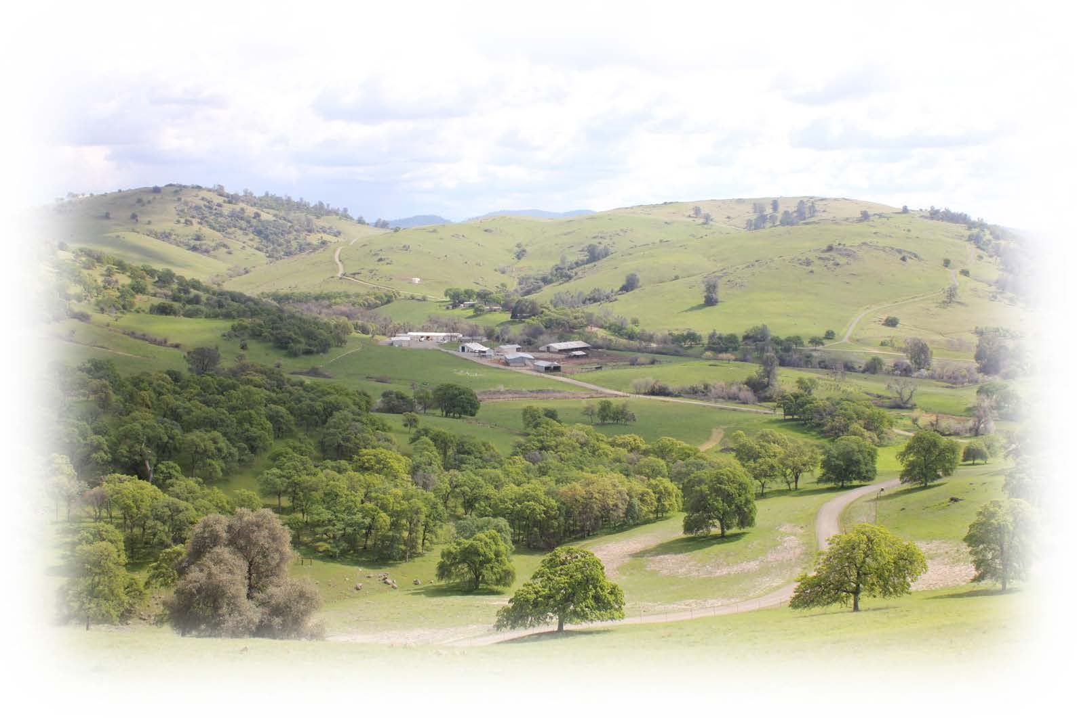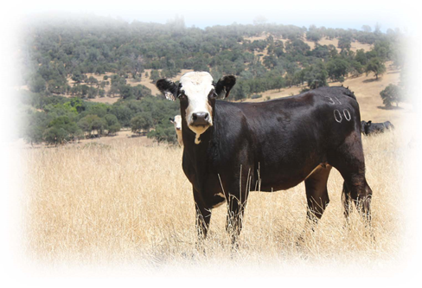

For further information regarding research opportunities, contact Dustin Flavell, SFREC Director at dkflavell@ucdavis.edu or Jackie Beck, Academic Programs Manager at jacbeck@ucanr.edu or visit sfrec.ucanr.edu
Sierra Foothill Research and Extension Center

