Rapid Recovery and Detection of
Phytophthora ramorum Propagules in Nursery Water

Douglas Luster, Karen Suslow, Supriya Sharma,³ Wolfgang Schweigkofler,³
and Vernon Huffman³

Abstract

Phytophthora ramorum, causal agent of sudden oak death, continues to threaten U.S. forest ecosystems and the nursery industry. Currently, USDA APHIS’s protocol (2014) utilizes the Bottle of Bait (BOB) recovery method for P. ramorum, which requires collecting water from a source, baiting with healthy rhododendron leaves for a 3-day incubation period, followed by plating on semi-selective media. Rapid methods are needed for recovery and detection of P. ramorum propagules from water sources. Working at the National Ornamentals Research Site at Dominican University of California (NORS-DUC), we are developing rapid water filtration and flocculation methods for recovery and detection of P. ramorum propagules from nursery irrigation water. A mock irrigation pond was established with flow from a P. ramorum- infested plot into an adjoining plot. Antibodies raised against P. ramorum -specific secreted proteins were applied for detection of zoospores and sporangia from 1 L samples in filter extracts or alum flocculates using standard immunoassay procedures. Results with spiked samples indicate that propagules of P. ramorum recovered by filtration or flocculation from spiked nursery water samples can be detected in 24 h or less.

Introduction
Presently, USDA APHIS (2014) relies upon water baiting for diagnosis and confirmation of Phytophthora ramorum in nurseries inside the boundaries of the P. ramorum regulated areas. As of March 31, 2014, the Confirmed Nursery Protocol utilizes the Bottle of Bait (BOB) technique for recovery of P. ramorum from standing water on nurseries and from water sources such as container runoff, irrigation retention ponds, etc. The process, as described in the Official Regulatory Protocol for Nurseries Containing Plants Infected with Phytophthora ramorum,
Confirmed Nursery Protocol: Version 8.2 (see: https://www.aphis.usda.gov/plant_health/plant_pest_info/pram/downloads/pdf_files/ConfirmedNurseryProtocol.pdf) can take as long as two weeks to obtain results.
We have been developing methods for rapid concentration, recovery, and detection of P. ramorum propagules from nursery water sources. To this end we have tested rapid microfiltration and flocculation techniques combined with antibody detection to reduce the time required to detect and identify P. ramorum. Microfiltration of nursery water sources has been used to recover pathogens for detection (e.g Ali-Shtayeh and others 1991, Hwang and others 2009). Flocculation is a standard practice in municipal drinking water treatment for removal of human pathogens (Andreoli and Sabogal-Paz 2019, EPA 2008, Engelhardt 2010), and has been tested in nurseries for removal of waterborne plant pathogens (Machado and others 2013, Majsztrik 2017). Both microfiltration and flocculation are rapid and inexpensive and hold promise to reduce the time required to detect and identify P. ramorum and other waterborne plant pathogens in nursery water sources.

In this study, we used monoclonal and polyclonal antibodies generated against P. ramorum secreted proteins and used them in ELISA immunoassays of filtrates and flocculates captured from a simulated nursery retention pond containing P. ramorum propagules, generating results in 24 hrs. or less.

Methods and Materials
Retention Pond Construction and infestation with P. ramorum
An open retention pond was constructed at NORS-DUC using existing facilities, in plots covered with mesh screening but open to receive rainfall (fig. 1A). The retention pond consisted of a raised bed plot with pool liner. An adjacent plot was infested with 6 mesh bags each containing 6 Rhododendron ‘Cunningham’s White’ leaves inoculated with P. ramorum NA1. Overhead irrigation was provided to the infested plot over the infested leaf bags for 5 minutes, twice daily, and the irrigation/rainfall runoff was captured and diverted to the retention pond. New inoculum bags were added to the plot monthly. The objective was to generate P. ramorum propagules in the adjacent plot and flush them into the retention pond, simulating runoff from an infested nursery.

Baiting and sampling
Water was sampled every two weeks between January- May 2019. Three 1 L plastic bottles were filled at the location where irrigation/rainfall runoff entered the retention pond. The three bottles from each sampling were analyzed independently. Baiting of the retention pond was conducted using mesh bags containing 6 Rhododendron ‘Cunningham’s White’ leaves (fig .1B). Bait bags were replaced every month. Leaf discs from baited leaves were plated on PARPH-V8 medium (Ferguson and Jeffers 1999) and examined microscopically for P. ramorum growth.
B
A
B

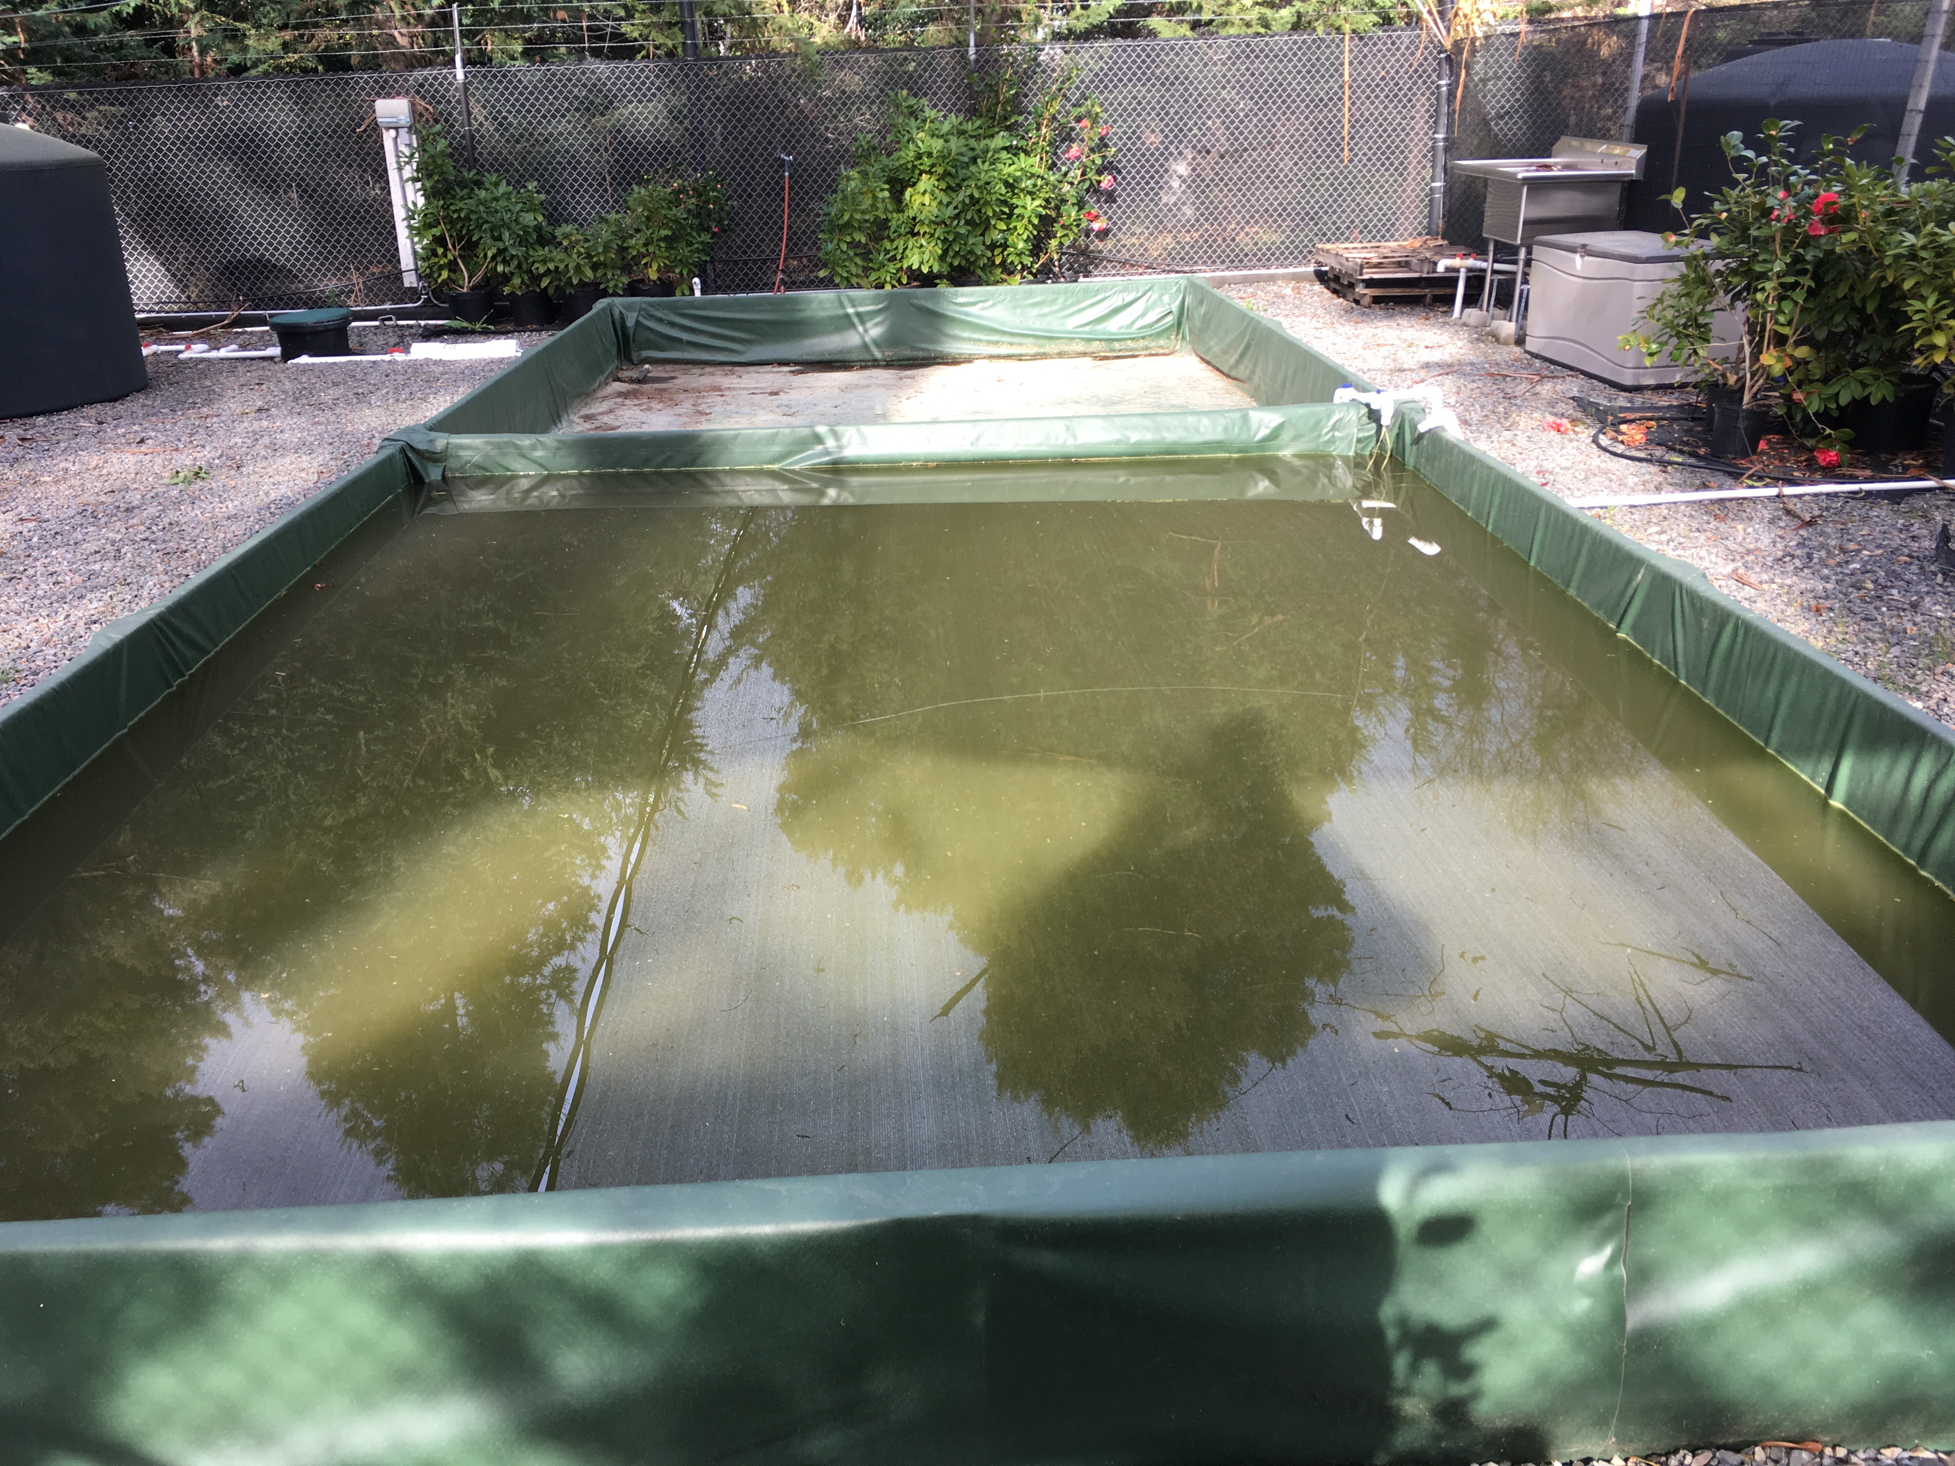
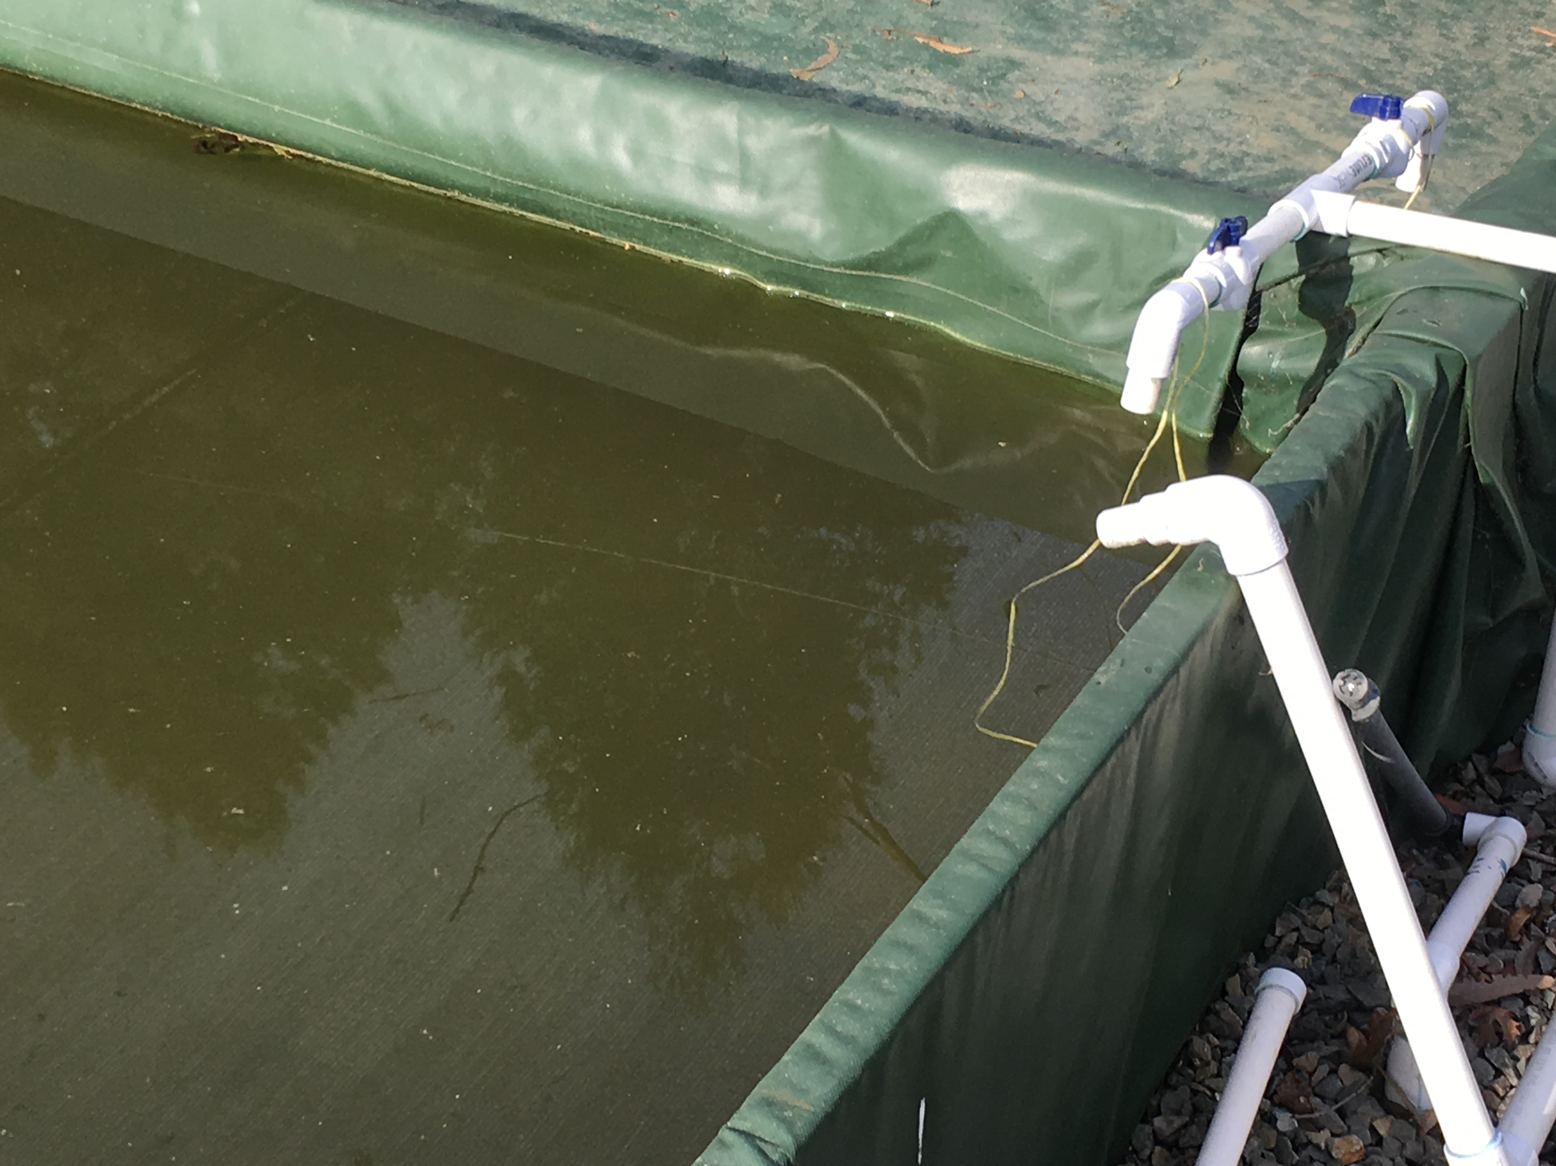

Figure 1. Arrows point to bait bags in mock retention pond placed at inflow from adjacent plot; water samples were collected there. A. Mock retention pond configuration in NORS-DUC plot. B. Close-up of inflow from adjacent plot and sampling point.

Microfiltration
Water samples from the runoff pond were used to test microfiltration protocols, refining methods from Ali-Shtayeh and others (1991) and Hwang and others (2009). Laboratory trials were conducted to trap zoospores from 1.0 L batches of retention pond water. A subset of the samples were spiked with known quantities of zoospores, produced from sporangial samples generated from cultures of P. ramorum NA1 (Widmer 2009). When necessary, samples were pre-filtered through 149-53-20 µ nylon mesh macro filters (Spectrum, New Brunswick, NJ) to clarify the sample and remove silt and debris. Samples were then filtered through 5µ polyvinylidene fluoride (PVDF) membrane filters (MilliporeSigma, Rockville, MD). Filters were incubated overnight (15-18 h) at 20 ºC in moist petri dishes to encourage zoospore encystment and germination. After incubation, filters were extracted in plant extraction buffer bags using GEB2 buffer (Agdia, Elkhart IN). After overnight incubation, filters were placed in bags with 3 mL of buffer, rubbed vigorously with the blunt end of a felt-tip marker pen, and extracts were frozen for ELISA assays.

Flocculation
Three 1 L water samples from the runoff pond, spiked and unspiked with known quantities of zoospores, were used to test flocculation protocols for collection and concentration of P. ramorum propagules. Water samples were transferred to clear plastic 500 mL bottles containing a 5 cm stir bar and stirred at 125 rpm at room temperature. The pH was measured with test strips; samples were consistently pH 6.5-7. While stirring at 125 rpm, 50 mL of fresh 1 mg/mL AlSO4 (“Alum”, Sigma Chemical Co., St. Louis, MO) was slowly added to a final concentration of 50 mg in 500 mL and the solution was stirred for 10 min. The stir plate was turned off after 10 minutes and the resultant fluffy flocculant allowed to settle for 60 minutes until the supernatant was clear (fig. 2A). The clear supernatant was slowly pipetted into a beaker and the flocculant (ca. 25 ml) was removed to a 50 mL, then to a 15 mL disposable plastic centrifuge tube and allowed to continue to settle (fig. 2B). An aliquot of the resulting flocculant (ca 5 mL) was dilution plated on PARPH-V8 to calculate recoveries and the remainder frozen for ELISA assays.

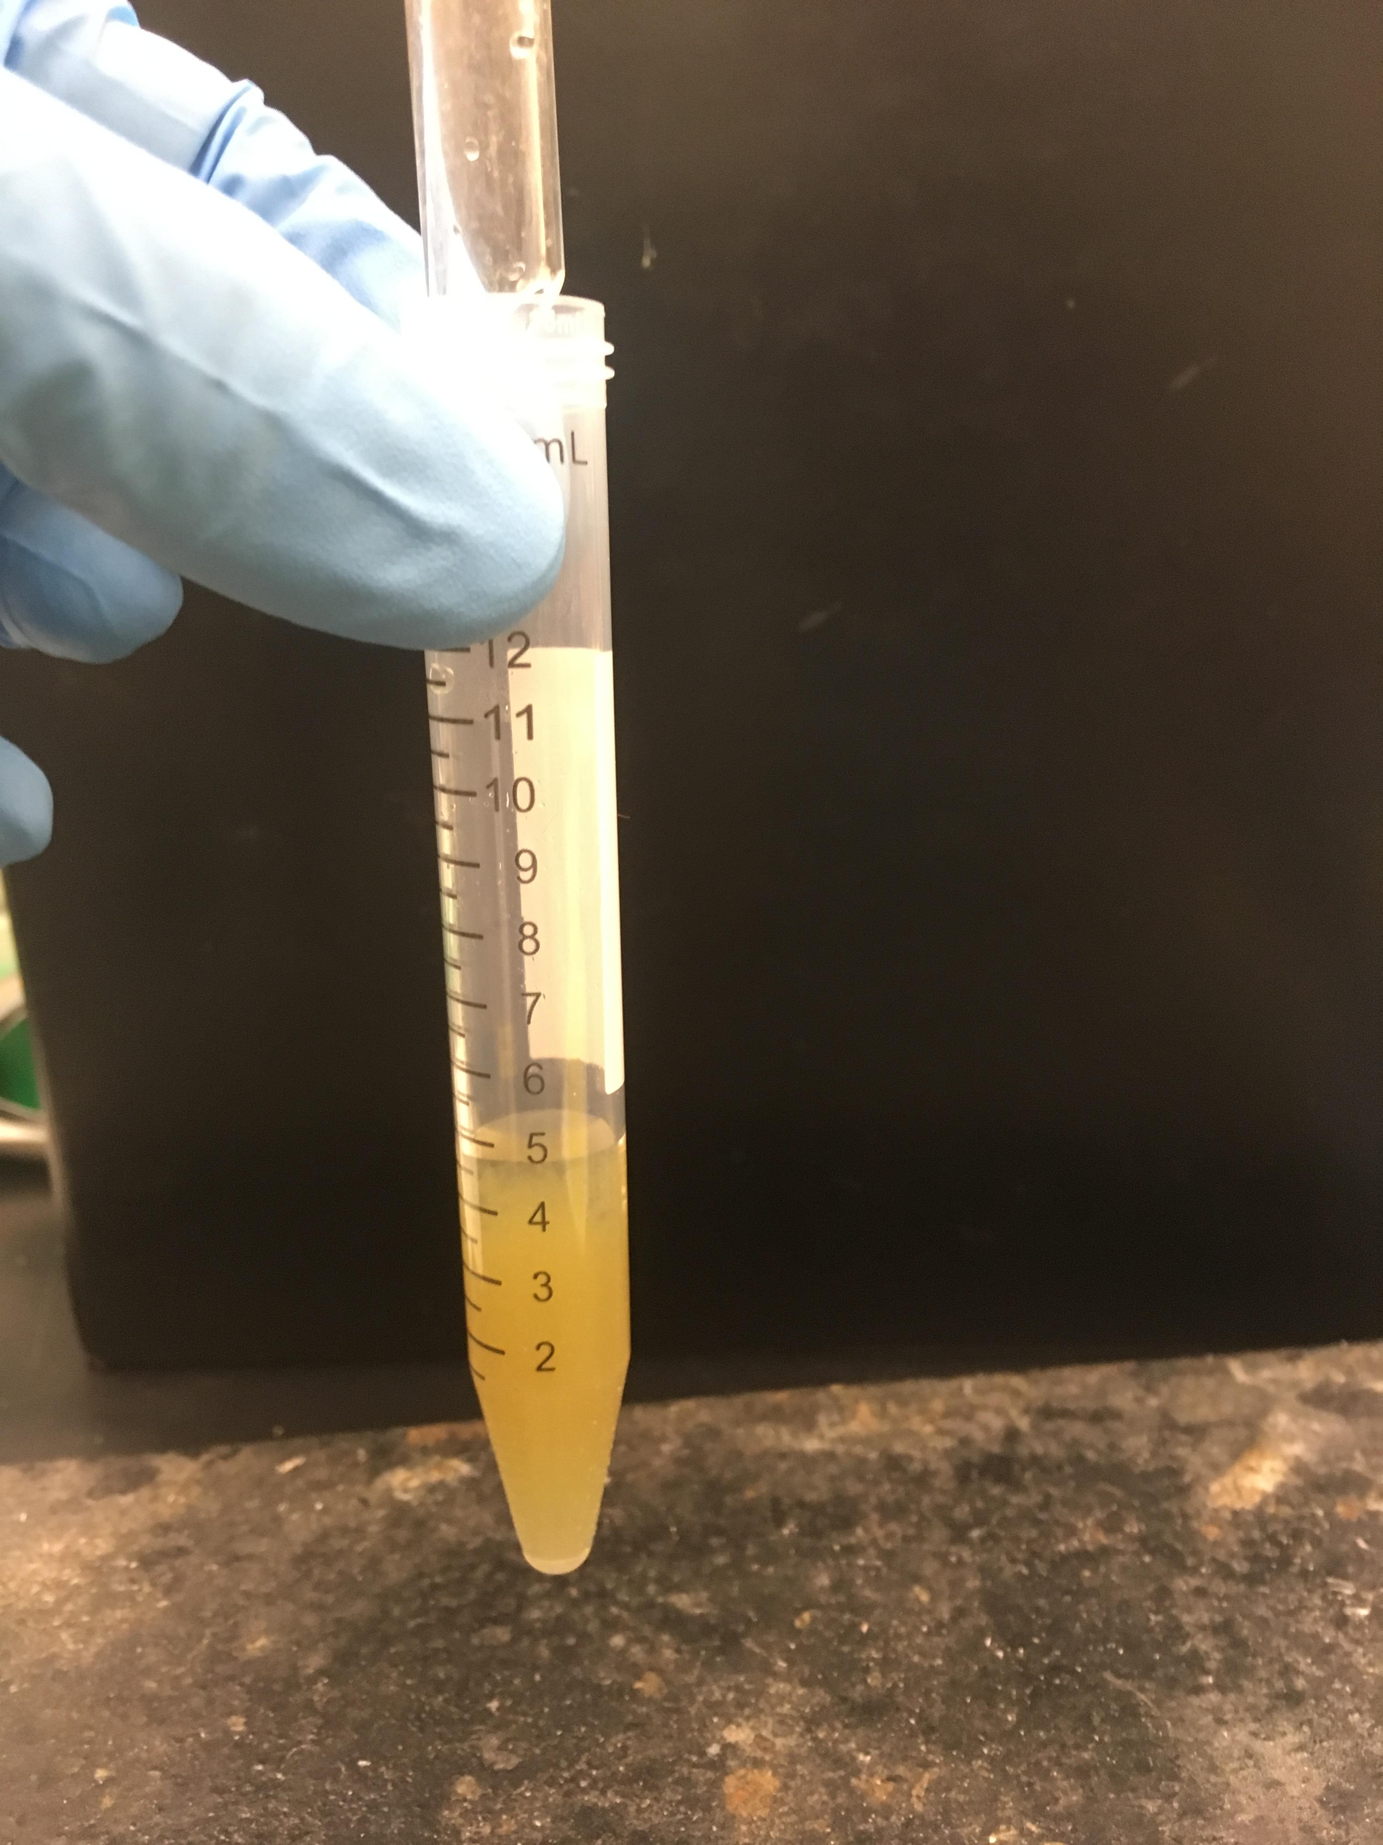
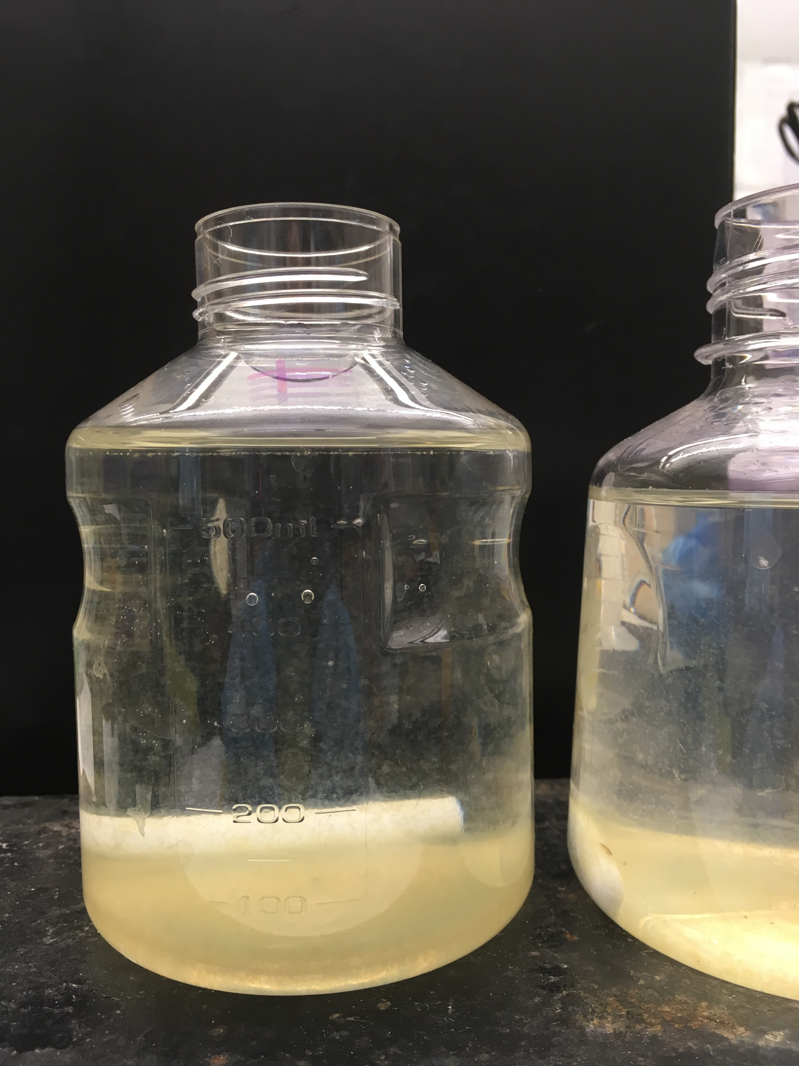
A
B

Figure 2. A. Nursery water sample 60 minutes after 50 mg alum flocculant was added with stirring and the flocculate allowed to settle. B. Concentrated flocculant from a 1L nursery water sample.

P. ramorum antibodies
Antigen targets for antibody development were identified using a mass spectrometry proteomic approach to identify proteins secreted by encysting zoospores in culture, referencing an annotated P. ramorum NA1 genome. Proteins with high antigenicity scores were BLASTed against all Phytophthora genomes in GenBank to identify those unique to P. ramorum, and unique proteins were selected for recombinant protein or peptide generation and antibody production in mice (monoclonal antibodies, mAbs) or rabbits (polyclonal antibodies, pAbs). One secreted protein unique to P. ramorum (“H3N7”) and found at the highest titer in secreted fractions on encysting zoospores, was selected for assays. Inclusivity testing was conducted against encysting zoospores of 14 NA1, NA2, EU1 and EU2 P. ramorum isolates. In laboratory tests, we have determined the sensitivity of these antibodies to be on the order of 10² to 10³ P. ramorum propagules (data not shown). Exclusivity testing against near neighbor Phytophthora spp. is still in progress to demonstrate specificity.

ELISA
ELISA assays were conducted on 100 µL samples of filtrate extracts or concentrated flocculate using the method described by Baysal-Gurel and others (2008), substituting ABTS (KPL, Gaithersburg, MD) as the enzymatic peroxidase conjugate substrate, reading absorbance at 405 nm.

Results
As presented in table 1, the recovery of sporangia in flocculates from spiked samples was 60-70%, while recovery of zoospores from similarly spiked samples was 40-60%. The P. ramorum mAb was able to detect both sporangia and zoospores in flocculates, while the pAb was less effective (Agdia Phytophthora immunostrips were used as a check). We observed clumping of encysting zoospores and sporangia in flocculants which may have reduced the observable number of colony-forming units (CFU) on culture plates and inhibited detection of propagules to microtiter well plates. We are currently testing mild surfactants and chaotropes on flocculates to reduce aggregation and provide more reliable results.

Table 1. Recovery of P. ramorum zoospores and sporangia in flocculates of 2019 nursery water samples spiked with the indicated propagules. ELISA Results Symbol Key: O.D. above background: < 0.1 = (-), 0.3-0.1= (+), 0.5-0.3 = (++), > 0.5 = (+++)

Sample Date/Type | Description | Agdia Strip | ELISA (pAb) | ELISA (mAb) | CFU (% Recovery)
Feb 20 | +Zoospores | + | + | + | 70%
Mar 14 | +Zoospores | + | + | + | 70%
Mar 22 | +Zoospores | + | + | + | 70%
Apr 1 | +Zoospores | + | + | + | 70%
Apr 25 | +Zoospores | + | ++ | + | 60%
May 8 | +Zoospores | + | ++ | + | 60%
Feb 20 | + Sporangia | + | ++ | ++ | 40%
Mar 14 | + Sporangia | + | + | + | 60%
Mar 22 | + Sporangia | + | - | + | 60%
Apr 1 | + Sporangia | + | - | + | 50%
Apr 25 | + Sporangia | + | - | + | 40%
May 8 | + Sporangia | + | - | + | 40%

Bait bag sampling in plot 11 was positive for P. ramorum in samples collected in February, March, April and May 2019 (table 2). This indicated that our mock retention pond design and operation was effectively generating P. ramorum propagules and flushing them from the infested source plot into the mock retention pond. Bait samples were not collected in January, and in some samples other Phytophthora spp. were present.

Phytopthora ramorum was detected by immunoassay with mAbs and pAbs in micro-filtered and flocculant samples from January, February, March, April and May 2019, indicating successful recovery and detection of P. ramorum propagules on filters. We also detected P. ramorum by immunoassay in flocculant samples from January, February, March, April and May 2019. The P. ramorum mAb was again able to both detect sporangia and zoospores in flocculates, while the pAb was slightly less effective in some cases.

Table 2. Results of 2019 baiting and immunoassays on nursery water sample microfiltrate extracts. N.D. = Not Determined. ELISA Results Symbol Key: O.D. above background: < 0.1= (-) , 0.3-0.1 = (+), 0.5-0.3 = (++), > 0.5 (+++)

Sample Date/Type | Baiting* | Agdia Strip | ELISA (pAb) | ELISA (mAb)
Jan 23 Bottle 1 | N.D. | + | ++ | +++
Jan 23 Bottle 2 | N.D. | + | + | +
Jan 23 Bottle 3 | N.D. | + | + | ++
Feb 7 Bottle 1 | P.ramorum + | + | ++ | ++
Feb 7 Bottle 2 | P.ramorum + | + | + | +++
Feb 7 Bottle 3 | P.ramorum + | + | + | ++
Feb 19 Bottle 1 | N.D. | + | + | +
Feb 19 Bottle 2 | N.D. | + | - | +
Feb 19 Bottle 3 | N.D. | + | + | +
Mar 14 Bottle 1 | P.ramorum + | + | ++ | ++
Mar 14 Bottle 2 | P.ramorum + | + | + | +
Mar 14 Bottle 3 | P.ramorum + | + | + | ++
Mar 22 Bottle 1 | P.ramorum + | + | + | ++
Mar 22 Bottle 2 | P.ramorum + | + | + | ++
Mar 22 Bottle 3 | P.ramorum + | + | + | +++
Apr 1 Bottle 1 | P.ramorum + | + | ++ | +++
Apr 1 Bottle 2 | P.ramorum + | + | +++ | +++
Apr 1 Bottle 3 | P.ramorum + | + | +++ | ++
Apr 25 Bottle 1 | P.ramorum + | + | + | ++
Apr 25 Bottle 2 | P.ramorum + | + | ++ | ++
Apr 25 Bottle 3 | P.ramorum + | + | + | ++
May 8 Bottle 1 | P.ramorum + | + | + | +
May 8 Bottle 2 | P.ramorum + | + | ++ | +
May 8 Bottle 3 | P.ramorum + | + | ++ | +

Discussion
Microfiltration and flocculation are effective methods for concentration of microbes from water samples, and when combined with immunoassays provide a rapid means of detection, with advantages over the baiting and culturing methods currently employed in detection of P. ramorum in nursery water sources. Filtration and flocculation are sampling methods that rely on detectable numbers of propagules in the water sample captured at a single time point, while baiting has the advantage of a retrieval method based upon zoospore chemotaxis and thus has a much larger effective sample volume. The tradeoff is thus time of sampling to detection vs. sensitivity. In this study we did not quantify P. ramorum propagules, but set the detection limit in ELISA at a low level of absorbance above controls/background.

Microfiltration can be a less useful method for propagule concentration when samples contain excessive sediment or algal growth, causing slow filtration or complete clogging of filters. In such cases flocculation may be the preferred method. Because flocculation has been demonstrated to be effective in removal of bacterial and protozoan pathogens from municipal water sources, we assume that our methods can be improved to demonstrate effective recoveries (or recovery quantification).

We have demonstrated that propagules of P. ramorum recovered by filtration or flocculation from spiked nursery water samples can be detected in 24 h or less. With improvements, these methods may provide alternatives to the current protocols required by regulatory agencies for detection of P. ramorum in surface waters.

Acknowledgements

Funding for this project was provided by USDA APHIS 10007 Farm Bill # 16-8130-0652-CA, #AP18PPQS&T00C174 and USDA-ARS NACA #58-8044-8-001-N.

Literature Cited

Ali-Shtayeh, M.S.; MacDonald, J.D.; Kabashima, J. 1991. A method for using commercial ELISA tests to detect zoospores of Phytophthora and Pythium species in irrigation water. Plant Disease. 75: 305-311.

Andreoli, F.C. and Sabogal-Paz, L.P. 2019. Coagulation, flocculation, dissolved air flotation and filtration in the removal of Giardia spp. and Cryptosporidium spp. from water supply. Environmental Technology. 40: 654-663.

Bush, E.A.; Hong, C.X.; Stromberg, E.L. 2003. Fluctuations of Phytophthora and Pythium spp. in components of a recycling irrigation system. Plant Disease. 87: 1500-1506.

Engelhardt, T.L. 2010. Coagulation, flocculation, and clarification of drinking water. Drinking water sector, Hach Company Technical Bulletin. https://pdfs.semanticscholar.org/41df/6382693e015bb060f5effd76301bc2fcdd81.pdf

EPA Report 2008. Large-Volume Sample Preparation for Waterborne Pathogens, EPA, Office of Water Research and Development, Cincinnati, OH. https://www.epa.gov/water-research/development-and-evaluation-large-volume-sample-preparation-techniques-microbial.

Ferguson, A.J. and Jeffers, S.N. 1999. Detecting multiple species of Phytophthora in container mixes from ornamental crop nurseries. Plant Disease. 83: 1129-1136.

Hwang, J.; Oak, S.W.; Jeffers, S. 2008. Detecting Phytophthora ramorum and other species of Phytophthora in streams in natural ecosystems using baiting and filtration methods. In: Frankel, S.J.; Kliejunas, J.T. and Palmieri, K.M., tech. coords. Proceedings of the Sudden Oak Death Third Science Symposium. Gen. Tech. Rep. PSW-GTR-214. Albany, CA: U.S. Department of Agriculture, Forest Service, Pacific Southwest Research Station. 55-58 p.

Machado, P.D.S.; Alfenas, A.C.; Coutinho, M.M.; Silva, C.M.; Mounteer, A.H.; Maffia, L.A.; de Freitas, R.G. and Freitas, C.D.S. 2013. Eradication of plant pathogens in forest nursery irrigation water. Plant Disease. 97: 780-788.

Majsztrik, J.C.; Fernandez, R.T.; Fisher, P.R.; Hitchcock, D.R.; Lea-Cox, J.; Owen, J.S.; Oki, L.R. and White, S.A. 2017. Water use and treatment in container-grown specialty crop production: a review. Water, Air, and Soil Pollution. 228:151.

USDA APHIS 2014. Official Regulatory Protocol (Confirmed Nursery Protocol: Version 8.2) for Nurseries Containing Plants Infected with Phytophthora ramorum.
http://www.aphis.usda.gov/plant_health/plant_pest_info/pram/downloads/pdf_files/ConfirmedNurseryProtocol.pdf

Widmer, T.L. 2009. Infective potential of sporangia and zoospores of Phytophthora ramorum. Plant Disease. 93: 30-35.

A version of the paper was presented at the Seventh Sudden Oak Death Science and Management Symposium, June 25-27, 2019, San Francisco, California.
U.S. Department of Agriculture, Agricultural Research Service, Foreign Disease-Weed Science Research Unit, Ft. Detrick, MD 21702.
National Ornamentals Research Site at Dominican University, Dominican University of California, San Rafael, CA 94901. Corresponding author: D. Luster, doug.luster@usda.gov.

