Susceptibility of Canadian Flora to EU2 Lineage of Phytophthora ramorum and Pathogen Sporulation Potential

Simon Francis Shamoun, Grace Sumampong,² Robert Kowbel,² Katherine Bernier,² Marianne Elliott, Danny Rioux, Martine Blais,⁴ and Alexandra Schlenzig

Abstract
Phytophthora ramorum is an oomycete pathogen and causal agent of a disease commonly referred to as sudden oak death (SOD). The pathogen also causes foliar blight and shoot dieback of nursery plants, including Rhododendron and Viburnum. It is responsible for the widespread mortality of tanoak (Notholithocarpus densiflorus) and coast live oak (Quercus agrifolia) in coastal California and southwestern Oregon, as well as Japanese larch (Larix kaempferi) in the U.K. Thirty-three plant host species commonly found in eastern (8) and western (25) Canadian landscapes and forest sites were selected for this study. Detached leaves/needles were inoculated with P. ramorum EU2 lineage mycelia which was isolated from a stream bait near an infected larch plantation in Scotland, U.K. There was a large variation in aggressiveness and sporulation potential among the evaluated hosts. Among the non-conifer species, the EU2 isolate produced the largest lesions on Pacific dogwood (Cornus nuttallii), Camellia japonica (western species); red oak (Quercus rubra), yellow birch (Betula alleghaniensis), and white ash (Fraxinus americana) (eastern species). For conifer hosts, we found that the EU2 isolate was most aggressive on both balsam fir (Abies balsamea) in the east and grand fir (Abies grandis), western hemlock (Tsuga heterophylla), and western larch (Larix occidentalis) in the west. As for sporulation potential, red alder (Alnus rubra) and bigleaf maple (Acer macrophyllum) in the west produced significantly more sporangia than California bay laurel (Umbellularia californica). Sugar maple (Acer saccharum) in the east was a potential spore producer but not significantly different from California bay laurel. Among the conifer species, western hemlock needles in the west were asymptomatic but produced a small amount of sporangia. The conifer host that produced the most sporangia/mm² lesion area was white spruce (Picea glauca) in the east and Sitka spruce (Picea sitchensis) in the west, which produced significantly more sporangia than California bay laurel in trial 1 but not in trial 2. Lesion area was biggest on grand fir (Abies grandis), balsam fir, and western larch. These results confirm the potential threat of EU2 lineage of P. ramorum to Canadian flora.
Introduction
Phytophthora ramorum is an oomycete pathogen and causal agent of a disease, commonly referred to as sudden oak death (SOD). The pathogen also causes foliar blight and shoot dieback of nursery plants, including Rhododendron and Viburnum. The pathogen is responsible for the widespread mortality of tanoak and coast live oak in coastal California and southwestern Oregon, USA, as well as, Japanese larch in the U.K. There are four distinct clonal lineages of P. ramorum, one originally discovered in Europe, but also detected in nurseries and one forest location in western North America (EU1), a lineage recently detected in Europe (EU2), and two lineages present in North America (NA1 and NA2) (Shamoun and others 2018). The host range of P. ramorum is very broad (more than 120 host plants) (Shamoun and others 2018). Many of the host species are present in forested and urban areas in the west coast of the US and Canada. To better assess the risk posed by an exotic pathogen such as P. ramorum, it is often a good strategy to evaluate its capacity to infect plants prevalent in the area of interest. This approach has been used with success where potential hosts were identified by artificial infections before being found naturally infected by P. ramorum. For instance, Kalmia latifolia was first identified as highly susceptible to P. ramorum under laboratory conditions (Tooley and others 2004) and was thereafter found as a host in the U.K. [(DEFRA 2008, Plant Health Portal. www.defra.gov.U.K./planth/pra/sudd.pdf]. We published similar results when a larch species (Larix laricina) was found susceptible for the first time after artificial inoculations (Jinek and others 2008) before another larch (L. kaempferi) was reported heavily infected in plantations in the U.K. in 2009 (Webber and Brasier 2010, Webber and others 2010) (figs. 1 and 2).
In the U.K., the known distribution of the EU2 lineage is limited to southwest Scotland and Northern Ireland (NI) (King and others 2015). The EU2 lineage is almost exclusively the only lineage of P. ramorum in NI. The EU2 lineage has not been found in England and Wales. Only the EU1 lineage is present there (fig. 3). The objectives of the present study are to determine the susceptibility of selected Canadian flora to EU2 lineage, investigate pathogen sporulation potential, and its threat to Canadian flora as well as its impact on the nursery industry and on forest ecosystems.

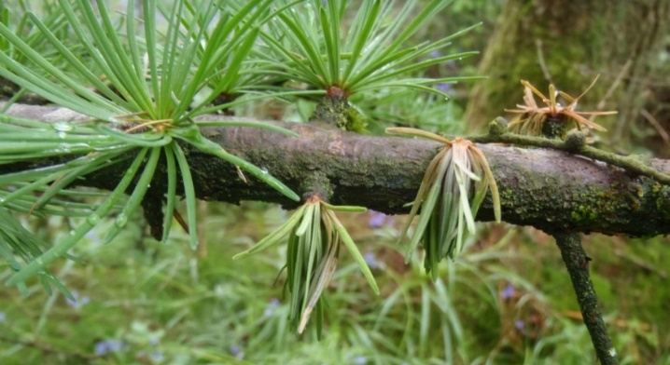

Figure 1 (left) —Needle symptoms of P. ramorum infection on Japanese larch (Courtesy: Mick Biddle, U.K. Forestry Commission). Figure 2 (right) —Crimson staining around P. ramorum infection of Japanese larch stem. Resin on the bark indicates stem infection (Courtesy: Mick Biddle, UK Forestry Commission).
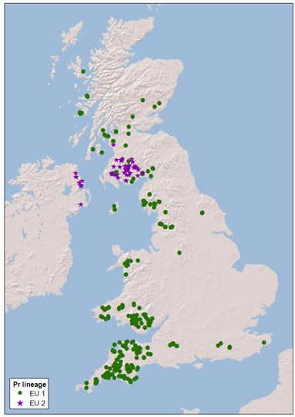
Figure 3 — Distribution map of P. ramorum lineages EU1 and EU2 in the U.K. (Courtesy: Dr. Joan Webber, U.K. Forestry Research).
Materials and Methods
Plant Species Tested
Thirty-three species of Canadian plants were selected from eastern and western Canada (tables 1 and 2). Mature, fully expanded foliage was collected in June 16 and 22, 2015, and July 11 and 25, 2016. Every attempt was made to collect from the same host plant to reduce variability due to host genetics and other factors.

Culture and Detached Leaves /Needles Inoculations
Detached leaves/needles representing eastern and western Canadian regions (tables 1 and 2) were inoculated with mycelia from a single isolate of P. ramorum EU2 (PFC5414), acquired under Canadian Food Inspection Agency (CFIA) Permit #P-2013-03068, from Dr. Alexandra Schlenzig (Scottish Agriculture and Rural Delivery Directorate, U.K.). This isolate was recovered from a stream bait near an infected larch plantation in 2012. Inoculation methods, assessment of lesion area and sporulation potential were conducted using the methods of Shamoun and others 2017, and the modified protocol of Harris and Webber 2016, respectively.
Table 1—Canadian host species collected from the Western Canadian region.

Scientific name | Common name
Arbutus menziesii | Madrone
Quercus garryana | Garry oak
Acer macrophyllum | Bigleaf maple
Alnus rubra | Red alder
Populus trichocarpa | Poplar
Cronus nuttallii | Pacific dogwood
Betula papyrifera | Paper birch
Camellia japonica | Camellia
Gaultheria shallon | Salal
Mahonia nervosa | Oregon grape
Rhododendron caucasicum | Rhododendron
Ribes spp. | Currant
Rubus discolor | Himalayan blackberry
Arctostaphylos spp. | Manzanita
Umbellularia californica | California bay laurel
Rubus idaeus | Raspberry
Vaccinium corymbosum | Blueberry
Vitus vinifera | Grape
Tsuga heterophylla | Western hemlock
Pinus contorta | Lodgepole pine
Larix occidentale | Western larch
Pseudotsuga menziesii | Douglas fir
Picea sitchensis | Sitka spruce
Abies grandis | Grand fir
Thuja plicata | Western red cedar

Table 2—Canadian host species collected from the Eastern Canadian region.

Scientific name | Common name
Betula alleghaniensis | Yellow birch
Acer saccharum | Sugar maple
Quercus rubra | Red oak
Fraxinus Americana | White ash
Gaultheria procumbens | Wintergreen
Rhus typhina | Sumac
Abies balsamea | Balsam fir
Picea glauca | White spruce

Healthy looking leaves and needles were collected, rinsed in sterile distilled water (sdH2O) twice and blotted with a paper towel to remove excess moisture prior to wounding and inoculation with an agar plug. Ten leaves were wounded next to the midrib using forceps, whereas conifer needles were cut at their base with a surface-sterilized scissor. After wounding, a 5 mm plug of P. ramorum EU2 lineage inoculum or blank V8 agar plug was placed mycelium side down over the wounded area on the abaxial side of the leaf or on three needles joined together at their base. After 10 days, leaves were photographed on a scanner and lesion size on each leaf caused by P. ramorum EU2 lineage was measured using ASSESS software (Lamari 2002) or measured with a ruler for needles. Lesion area was adjusted for the lesion caused by wounding in the blank (no inoculum) treatments and considered to be zero if the lesion is equal to or less than that caused by wounding alone.
Sporulation
The inoculated area of the leaf or needle surface and any visible necrosis beyond this was gently scraped with a rounded scalpel blade to free all sporangia from the same side where the leaf had been inoculated. A 200 uL droplet of sdH₂O was placed on the inoculated area to suspend the scrapings and then transferred to a 1.5 mL microtube to which 5 uL cotton blue (lactophenol blue) was added. Microtubes were centrifuged for 10 min at 6000 g at 4 °C. The total number of sporangia was counted in a pellet resuspended in 20 uL sdH₂O under the microscope.

Data Analysis
Trials 1 and 2 were analyzed separately since the homogeneity of variance test failed. T-tests between lesion area on inoculated and water-inoculated foliage were done for each host. A host was considered to be asymptomatically infected if p > 0.05. There was sufficient power to do 1-way ANOVA on lesion area and sporangia/unit lesion area. When ANOVA was significant Tukey's HSD and Dunnett's post-hoc tests were done. Lesion area was evaluated on foliage in five size class categories (table 3), since differences in lesion area relative to leaf area can be confounding. Sporangia per unit lesion area was analyzed for broadleaf and conifer hosts separately.

Table 3 —Classification of foliar hosts by relative leaf area.
Group | Hosts
Group A: Conifer needles | White spruce, western larch, Sitka spruce, Douglas fir, balsam fir, grand fir, lodgepole pine
Group B: Small size broadleaf | Western red cedar, wintergreen, manzanita
Group C: Medium size broadleaf | Currant, paper birch, Oregon grape, blueberry
Group D: Large size broadleaf | Sugar maple, Camellia, Sumac, Garry oak, rhododendron, yellow birch, salal, Himalayan blackberry, raspberry, madrone, white ash, Pacific dogwood, red alder, red oak
Group E: Extra large size broadleaf | Bigleaf maple, poplar, grape

Results and Discussion
There was a large variation in aggressiveness and sporulation potential among the evaluated hosts. Among the non-conifer species, the EU2 isolate produced the largest lesions on Pacific dogwood, (Cornus nuttallii), and Camellia japonica, on the western species (fig. 4); and red oak (Quercus rubra), yellow birch (Betula alleghaniensis), and white ash (Fraxinus americana) on the eastern species (fig. 5). For conifer hosts, we found that the EU2 isolate was most aggressive on balsam fir (Abies balsamea) (eastern species) and grand fir (Abies grandis), western hemlock (Tsuga heterophylla), and western larch (Larix occidentalis) (western species). As for sporulation potential, red alder (Alnus rubra) and bigleaf maple (Acer macrophyllum) (west species) produced significantly more sporangia than California bay laurel (Umbellularia californica). Sugar maple (Acer saccharum) (eastern species) was a potential spore producer but not significantly different from California bay laurel. For the sporangia per unit lesion area, Himalayan blackberry (Rubus discolor), raspberry (Rubus idaeus), and Garry oak (Quercus garryana) were significantly higher than California bay laurel, although both Himalayan blackberry and raspberry were asymptomatic. These results confirm the potential threat of EU2 lineage to Canadian flora.

Foliar hosts were classified by relative leaf area into five groups and these groups were analyzed separately (table 3).
Group A, Conifer needles: Western hemlock needles were asymptomatic but produced a small amount of sporangia. The conifer hosts that produced the most sporangia/mm² lesion area were Sitka spruce and white spruce, which produced significantly more sporangia than California bay laurel in trial 1 but not in trial 2. Lesion area was biggest on grand fir, balsam fir and western larch.
Group B, Small size broadleaf: This group included manzanita and wintergreen, both evergreen broadleaf plants. Lesion area was similar for both hosts, which tended to cover approximately 50% of the leaf area on average (data not shown). Both hosts produced fewer sporangia than California bay laurel. Western red cedar was in this size class but was asymptomatic. Sporangia production was highly variable on western red cedar and ranged from 0-157 sporangia/mm².
Group C, Medium size broadleaf: Blueberry and Oregon grape had smaller lesion area than paper birch and currant. The only host that produced abundant sporangia per mm² lesion area was Oregon grape, but was not significantly more than California bay laurel.
Group D, Large size broadleaf: The largest lesions were formed on yellow birch, which had similar sporangia/lesion area to California bay laurel. The average total sporangia per lesion produced by yellow birch was 21 and California bay laurel 186, respectively.
Group E, Extra-large size broadleaf: Lesion area on these three hosts tended to be small, but significantly more sporangia were produced on big leaf maple when compared to California bay laurel.
Figures 6 and 7 show results for lesion area of broadleaf foliage and conifer needles hosts inoculated with the EU2 lineage of P. ramorum, respectively. Figures 8 and 9, represent sporulation potential of EU2 lineage of P. ramorum on broadleaf foliage and conifer needles hosts, respectively.
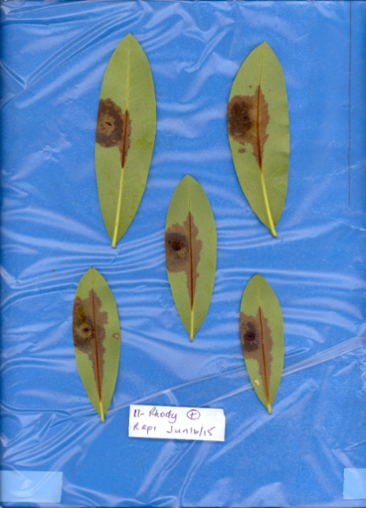
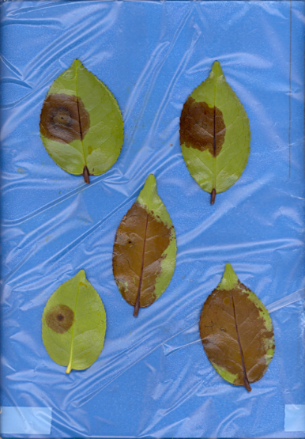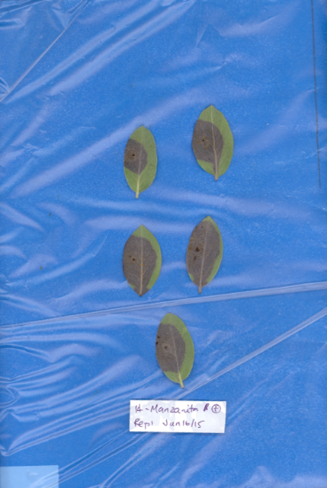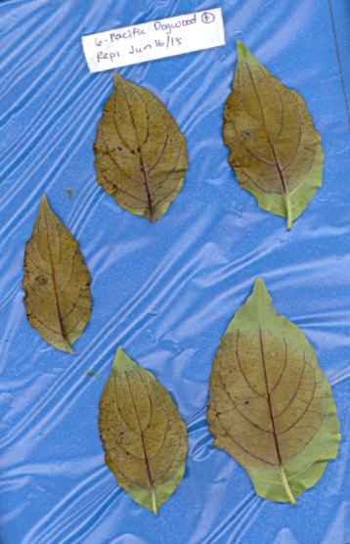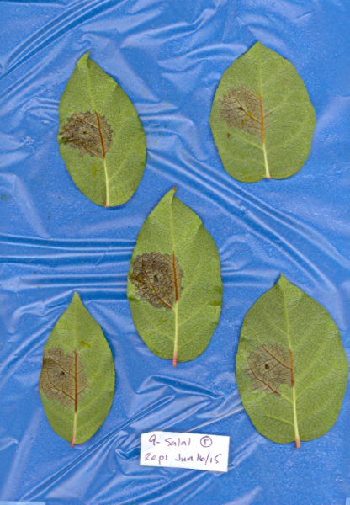
Figure 4 — Lesions formed by P. ramorum EU2 lineage on detached leaves of highly susceptible Western Canadian hosts. The upper 3 photos from left to right are camellia, manzanita, and Pacific dogwood. The bottom two photos from left to right are rhododendron and salal.
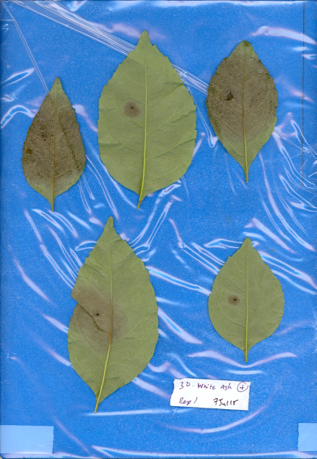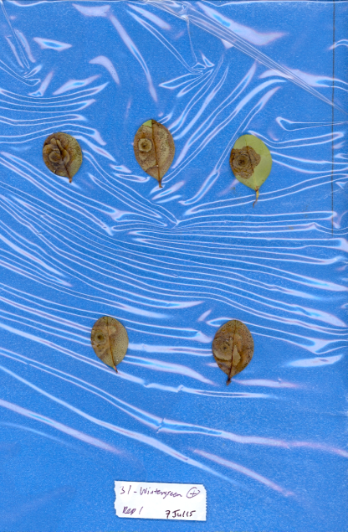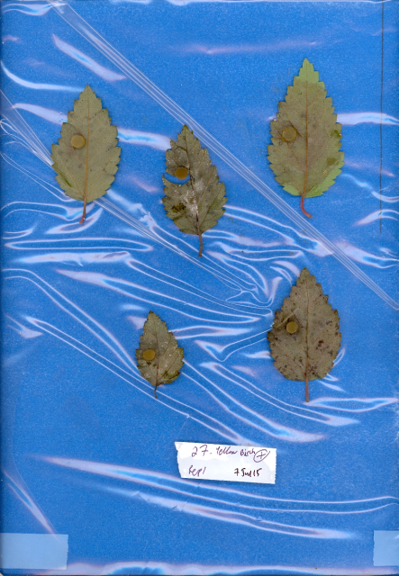
Figure 5 — Lesions formed by P. ramorum EU2 lineage on detached leaves of susceptible Eastern Canadian hosts: from left to right: white ash, wintergreen, and yellow birch.
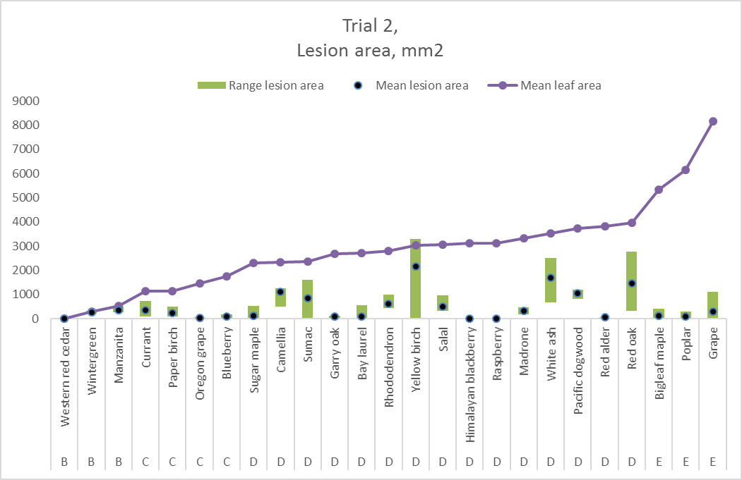
Figure 6 — Lesion area measured on broadleaf hosts inoculated with EU2 lineage of P. ramorum. Host foliage was separated into classes depending on total leaf area.

Figure 7 — Lesion area measured on conifer needles hosts inoculated with EU2 lineage of P. ramorum. Host foliage was separated into classes depending on total leaf area.

Figure 8 — Sporulation potential of EU2 lineage of P. ramorum on Canadian broadleaf host plants as determined by the total number of sporangia per lesion.

Figure 9 — Sporulation potential of EU2 lineage of P. ramorum on Canadian conifer hosts needles as determined by the total number of sporangia per lesion.
These results extend the known potential host range for P. ramorum EU2 lineage. The detached, in vitro, leaf/needle inoculation method of Elliott and others (2011) was used in the current investigation, as this method and other published SOD research work elsewhere are well established and applied as an approved APHIS/CFIA protocols for testing P. ramorum host range throughout North America (O’Hanlon and others 2017, Tooley and others 2004). The natural hosts for EU2 lineage include Japanese larch, European larch, hybrid larch, beech, grand fir, noble fir, western hemlock, rhododendron, red oak and Vaccinium (King and others 2015, Personal communication Dr Joan Webber). Molecular (Elliott and others 2009, King and others 2015, Van Poucke and others 2012) and phenotypic (Elliott and others 2011, Franceschini and others 2014, O’Hanlon and others 2017) characterizations and protocols have been designed to objectively discriminate the P. ramorum lineages, and these should be made routine for national and international regulatory agencies (e.g., APHIS, CFIA) and plant protection organizations in order to identify if different lineages are spreading.
Previous studies reported the EU2 lineage from Japanese larch, bilberry (Vaccinium myrtillus), rhododendron and non-native oak in the U.K. Furthermore, several scientists have provided the first confirmed findings of natural infection by EU2 lineage on European larch, hybrid larch, beech, noble fir and western hemlock (Franceschini and others 2014, King and others 2015, Van Poucke and others 2012). In our present study we have confirmed additional Canadian host plants to the potential host range for P. ramorum EU2 lineage. These observations suggest that EU2, like EU1 and NA2, is able to colonize a wide range of host species that may contribute to an increased risk of EU2 spread. Moreover, comparative experiments have shown that the EU2 lineage is more aggressive than EU1 lineage at colonizing larch bark tissue and is therefore likely to kill affected trees more rapidly (McCracken and others 2015, Webber and others 2014). Given these findings on Larix, prioritization of the eradication of EU2 lineage may be justified in order to contain the epidemic and protect forest/plant health ecosystems in the U.K. In addition, our study confirms the potential threat of the EU2 lineage of P. ramorum if it becomes established in Canadian nurseries and wildlands.

A draft genome assembly for the P. ramorum EU2 lineage has been collected from isolates from outbreak sites in Scotland (Sambles and others 2015). This information will enhance our understanding of the infection biology of the pathogen. Also, it will assist researchers worldwide in accelerating our knowledge of relationships between the four known lineages of P. ramorum (NA1, NA2, EU1 and EU2), as well as, the development of molecular diagnostic assays for detection and field monitoring of the EU2 lineage (King and others 2015, Sambles and others 2015). Furthermore, EU2 lineage will have a potential impact on the Canadian horticultural industry, biodiversity, and sustainability of forest ecosystems. Ongoing research is focused on further evaluation of sporulation potential of the EU2 lineage of P. ramorum on a subset of selected Canadian flora. The Canadian Forest Service mandate is to monitor the status of the EU2 lineage in the U.K. and work closely with the CFIA to update the existing Canadian Pest Risk Assessment (PRA) to address new relevant P. ramorum information as it arises.

Conclusions
- For broadleaf species, Pacific dogwood and camellia, in the west; and sumac, yellow birch, red oak, and white ash in the east, were the Canadian flora most susceptible to infection by the EU2 lineage.
- For conifer hosts, we found both balsam fir in the east and grand fir, western hemlock, and western larch in the west to be the most susceptible to EU2 lineage infection.
- These results extend the known potential host range of the EU2 lineage of P. ramorum; the known host range includes Japanese larch, grand fir, noble fir, rhododendron, red oak and Vaccinium in the U.K.
- There was high variability in sporulation potential within and among hosts. Ongoing research is focused on further evaluation of sporulation potential of the EU2 lineage on Canadian flora (i.e., to discover the “spore pump” host or hosts). Preliminary results indicate that maples and spruces have high sporulation potential and these groups will be investigated further.
- The Canadian Forest Service is closely monitoring the status of the EU2 lineage in the U.K. and working with the CFIA to update the existing Canadian Pest Risk Assessment (PRA) and address new relevant P. ramorum information as it arises.

Acknowledgments

We acknowledge the financial support for this project by Natural Resources Canada, Canadian Forest Service, Forest Pest Risk Management- Forest Invasive Alien Species (FIAS) Program. The authors are grateful to Dr. Joan Webber, Principal Plant Pathologist and Head, Tree Health, Forest Research, U.K. for providing us with the epidemiology information and distribution maps of P. ramorum EU1 & EU2 lineages in the U.K. In addition, we acknowledge Mick Biddle, Tree Health Officer, Forestry Service, Forestry Commission England for providing images of symptoms of sudden larch death of P. ramorum on Japanese larch.

Literature Cited

Elliott, M.; Sumampong, G.; Varga, A.; Shamoun, S.F.; James, D.; Masri, S.; Brière, S.C. and Grünwald, NJ. 2009. PCR-RFLP markers identify three lineages of North American and European populations of Phytophthora ramorum. For. Path. 39: 266-278.

Elliott, M.; Sumampong, G.; Varga, A.; Shamoun, S.F.; James, D.; Masri, S. and Grünwald, NJ. 2011. Phenotypic differences among three clonal lineages of Phytophthora ramorum. For. Path. 41: 7-14.

Franceschini, S.; Webber, J.F.; Sancisi-Frey, S. and Brasier, C.M. 2014. Gene x environment tests discriminate the new EU2 evolutionary lineage of Phytophthora ramorum and indicate that it is adaptively different. For. Path. 44: 219-232.

Harris, A.R. and Webber, J.F. 2016. Sporulation potential, symptom expression and detection of Phytophthora ramorum on larch needles and other foliar hosts. Plant Pathology 65(9): 1441-1451.

Jinek, A., Simard, M.; Brière, S.C.; Watson, A.K.; Teweddell, R.J. and Rioux, D. 2008. Susceptibility of six eastern Canadian forest species to Phytophthora ramorum. Phytopathology 98: S75 (Abstract).

Jinek, A.; Simard, M.; Brière, S.C.; Watson, A.K.; Teweddell, R.J. and Rioux, D. 2011. Foliage susceptibility of six eastern Canadian forest tree species to Phytophthora ramorum. Canadian Journal of Plant Pathology. 33: 26-37.

King, K.M.; Harris, A.R. and Webber, J.F. 2015. In planta detection used to define the distribution of the European lineages of Phytophthora ramorum on larch (Larix) in the U.K. Plant Pathology 64: 1168-1175.

Lamari, L. 2002. ASSESS 1.0 Image analysis software for plant disease quantification. APS Press, Saint Paul, MN., USA, 125 pp.

McCracken, A.R.; Quinn, L.M.; Wilson, M.A. and Webber, J.F. 2015. The comparative pathogenicity of two Phytophthora ramorum lineages, EU1 and EU2, on a range of hosts. In: Sutton, W., Reeser, P. and Hansen, E.M, eds. Proceedings of the 7th Meeting of the International Union of Forest Research Organizations Phytophthora in Forests & Natural Ecosystems. Esquel, Argentina: IUFRO Working Party 7– 02-09.

O’Hanlon, R.; Choiseul, J.; Grogan, H. and Brennan, J.M. 2017. In vitro characterization of the four lineages of Phytophthora ramorum. Eur. J. Plant Path. 147(3): 517-525.

Sambles, C.; Schlenzig, A.; O’Neill, P.; Grant, M. and Studholme, D.J. 2015. Draft genome sequences of Phytophthora kernoviae and Phytophthora ramorum lineage EU2 from Scotland. Genomics Data. 6: 193-194.

Shamoun, S.F.; Sumampong, G.; Rioux, D. and Schlenzig. A. 2017. Potential susceptibility of Canadian flora to EU2 lineage of Phytophthora ramorum. In: Frankel, S.J.; Harrell, K.M., tech. coords. Proceedings of the sudden oak death sixth science symposium. Gen. Tech. Rep. GTR-PSW-255. Albany, CA: U.S. Department of Agriculture, Forest Service, Pacific Southwest Research Station. Pages 91-98.
Shamoun, S.F.; Rioux, D.; Callan, B.; James, D.; Hamelin, R.; Bilodeau, G.; Elliott, M.; Levesque, C.A.; Becker, E.; McKenney, D.; Pedlar, J.; Bailey, K.; Briere, S.; Niquidet, K. and Allen, E. 2018. An overview of Canadian research activities on diseases caused by Phyophthora ramorum: Results, progress and challenges. Plant Disease. 102(7): 1218-1233.

Tooley, P.W.; Kyde, K.L. and Englander, L. 2004. Susceptibility of selected Ericaceous ornamental host species to Phytophthora ramorum. Plant Disease. 88: 993-999.

Van Poucke, K.; Franceschini, S; Webber, J.F.; Vercauteren, A.; Turner, J.A. and McCracken, AR. 2012. Discovery of a fourth evolutionary lineage of Phytophthora ramorum : EU2. Fungal Biology. 126: 1178-1191.

Webber, J. and Brasier, C. 2010. Plant Pathology: sudden larch death. Nature. 466: 825.
Webber, J.F.; Mullet, M.; Brasier, C.M. 2010. Dieback and mortality of plantation Japanese larch (Larix kaempferi) associated with infection by Phytophthora ramorum. New Disease Reports. 22: 19.

Webber, J.; Turner, J.; Thorpe, G. and McCracken, A. 2014. Differences between genotypes of Phytophthora ramorum in the U.K. in relation to risk and disease management. Forest Research final project. Report number FFG1142.

A version of this paper was presented at the Seventh Sudden Oak Death Science and Management Symposium, June 25-27 2019, San Francisco, California.
Natural Resources Canada, Canadian Forest Service, Pacific Forestry Centre, Victoria, BC, Canada V8Z 1M5.
Washington State University, Puyallup Research and Extension Centre, Puyallup, WA 98371.
Natural Resources Canada, Canadian Forest Service, Laurentian Forestry Centre, QC, Canada G1V 4C7.
Science and Advice for Scottish Agriculture (SASA), Plant Biosecurity and Inspections, Edinburgh, U.K. EH12 9FJ. Corresponding author: S. Shamoun, Simon.Shamoun@Canada.Ca.

