WALNUT HUSK FLY BIOLOGY, MONITORING, and SPRAY TIMING
Janine Hasey, UC Farm Advisor, Sutter, Yuba, and Colusa Counties

For some growers, walnut husk fly (WHF) is their primary orchard insect pest. The colorful husk fly has a yellow spot on its back, dark triangular bands at the wing tips, and is about the size of a house fly. English walnut varieties such as Tulare, Hartley, and Franquette are the most susceptible to husk fly damage although all varieties can be infested. Husk flies produce one generation per year overwintering as pupae in the soil. They emerge as adults in the Sacramento Valley from mid-June through September with peak emergence from mid-July to mid-August. About one percent of the pupae survive for two years in the soil.

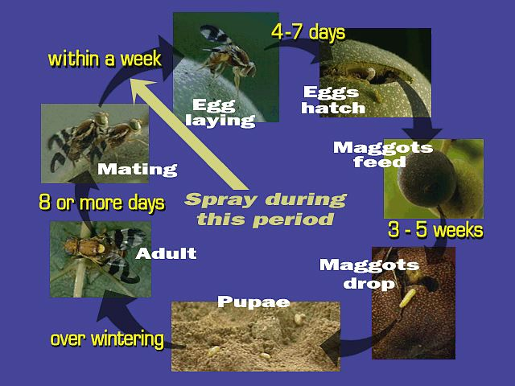
Life Cycle: Understanding the life cycle is important to spray timing and effective control. After emergence, it takes a female about 2 weeks to mate, develop eggs and start laying them into the walnut husk. The most effective spray timing is the period when the female is developing eggs before egg laying occurs. Once eggs are deposited, they hatch into white maggots within about 5 days and feed on the husk for 3 to 5 weeks before dropping to the ground, burrowing into the soil, and pupating.

Damage: First symptoms are the small “stings” in the husk where eggs were deposited. The husk turns black and soft as maggots feed inside the husk, causing stains on the nutshell which cannot be removed by normal bleaching. Stained shells cannot be sold in-shell. Early infestations can have a significant impact on kernel quality and substantially reduce the crop’s value.

Monitoring and Spray Timing: Since WHF is not driven by temperature and development is related to food availability, there are no degree-day models as with codling moth to time sprays. Each orchard must be monitored for husk fly activity to decide if and when to treat. Yellow sticky traps charged with an ammonium carbonate lure work best. For information on performance of various traps and lures see Walnut Research Reports 2012 at http://walnutresearch.ucdavis.edu. Past damage and “hot spots” will help with trap placement; hang two traps every 10 acres. Walnut husk fly is not likely to stay confined to a single orchard if there are other walnut orchards within ½ mile.

Monitoring options: Visit the UC IPM Pest Management Guidelines website at http://ipm.ucdavis.edu and click on walnut, then husk fly to get details, photos of sexing flies and finding eggs, and monitoring forms for the following methods (the first two have typically been effective):
- Monitor for eggs (the most accurate)
    - Time spray when the first female with eggs is found
  - Monitor trap catches
    - Spray when a sharp increase occurs
    - If using GF 120 in low population orchards, spray at 1st fly.
  - Monitor for stings
            - Spray at 1st sting (but damage has occurred)
2013 – With increased WHF pressure, apply sprays when flies are caught on traps rather than waiting for a sharp increase in trap catches.
- Continue monitoring through the season. Typically there is a 3 week interval between sprays. Treat up to 3 weeks before harvest.
  - After emergence, it takes 2 weeks for a female to mate and develop eggs before she starts laying.
  - A short-residual insecticide plus bait will generally kill WHF for about 7- 10 days.
- The 3 week interval is based on killing all the flies with the previous spray

Treatment Options: There are several insecticides, both for conventional and organic orchards, effective against husk fly and all should have bait added to the treatment except GF-120 (contains its own bait). Full coverage is not that critical if you add bait which lures the fly to the treated leaves where it comes into contact with the insecticide. The exceptions are high population orchards with extensive previous damage; these should have full coverage sprays at full rates of insecticides and bait with every row sprayed. The UC IPM website above lists insecticides, baits and rates to use for WHF control. Aphid control will also help reduce the movement of husk flies within and between orchards by reducing the sugary food source of aphid honeydew.

Walnut

Identifying Mated Female Walnut Husk Flies
If you choose to monitor for eggs using a dissecting scope or hand lens, use the photos below to help identify gender and recognize eggs. At the first appearance of gravid (with eggs) females there is about one week before egg laying occurs but plan to spray immediately. This procedure is not used if you are using GF-120 bait because these sprays need to be applied as soon as flies are caught rather than waiting for the gravid females. Names link to more information on identification and management.
Walnut husk flies  Identification tip: Distinguish females from males by looking at the legs: the first leg segment of the female walnut husk fly is yellow, while the male is dark. | Identification tip: To determine if a female has mated, gently crush the abdomens of females with a pointed tool, and use a hand lens or dissecting microscope to look for tiny white eggs. | Identification tip: In the photo above there are about 7 eggs squeezed from a female mated husk fly. These eggs resemble small grains of rice.

Statewide IPM Program, Agriculture and Natural Resources, University of California
All contents copyright © 2008 The Regents of the University of California. All rights reserved. .

