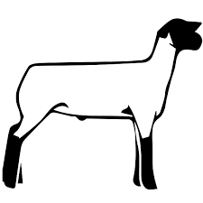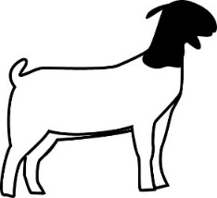

**FANTASTIC FIELD DAY**

**LIVESTOCK JUDGING ACTIVITY**

**February 22, 2025 – Salinas Valley Fair Grounds**

**Hosted by Chualar 4-H**

The purpose of Livestock Judging is to give 4-H members the opportunity to exhibit their animal evaluation & identification skills at a fair.

Each participant will learn about Market Swine, Market Lambs, Market Goats, Dairy Goats, Dairy Cows, & Market Beef to enhance their knowledge of these species.

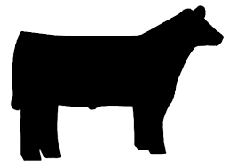

**A 4-H study guide on Market Livestock Judging can be found:**

[**http://cemonterey.ucanr.edu/4-H_Program/Curriculum_Resources/**](http://cemonterey.ucanr.edu/4-H_Program/Curriculum_Resources/)

**Goals: Members will learn about how a Livestock Judging contest would run at a local fair without being judged. Using visual techniques and accurate terminology, members will quickly learn how to identify healthy livestock. A 4-H member will learn the skills to be able to participate in a Livestock Judging competition at a local county fair.**

**Format for the Livestock educational activity during the rotation:**

* Each member will be given instructions by the Chualar club committee members.
* The members have an opportunity to review different species of livestock that would be shown at a fair for competition.
* All members will be given the proper names of livestock species and varieties.
* This will be a non-competitive rotation. Members can ask questions to help clarify and gain additional understanding.
* Material addressed will encompass today’s current market and breeding standards.
* 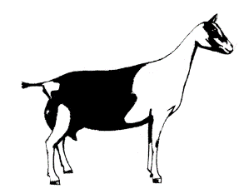Members will be given additional resources to go over at home.

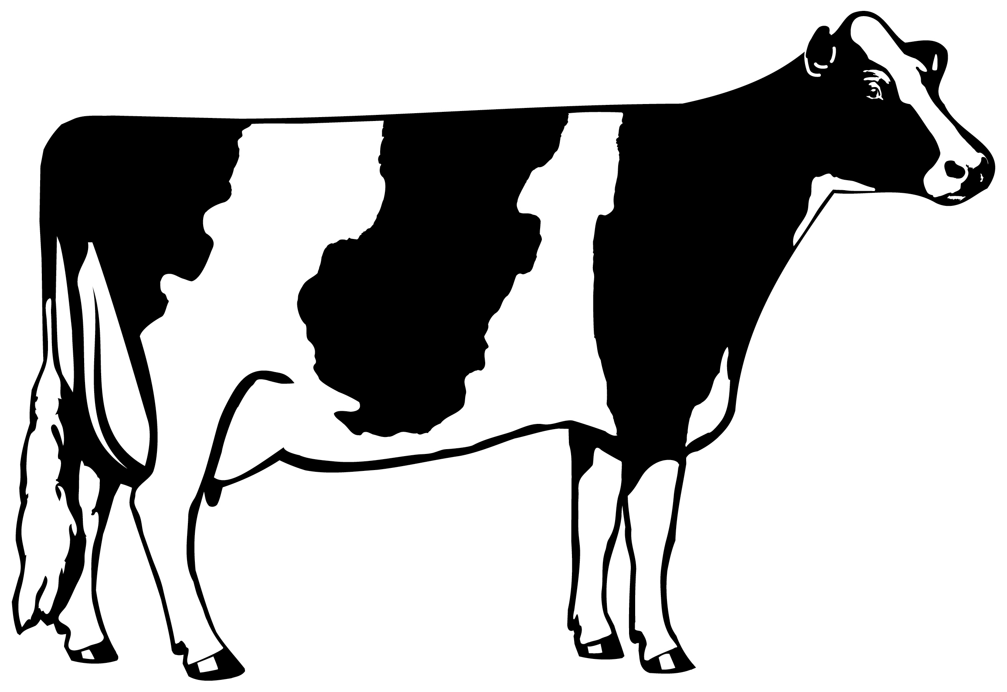

Have questions or ideas? Contact the Chualar 4-H Club at: [chualar4hclub@gmail.com](mailto:chualar4hclub@gmail.com)

It is the policy of the University of California (UC) and the UC Division of Agriculture & Natural Resources not to engage in discrimination against or harassment of any person in any of its programs or activities (Complete nondiscrimination policy statement can be found at <http://ucanr.edu/sites/anrstaff/files/215244.pdf> )

Inquiries regarding ANR’s nondiscrimination policies may be directed to John I. Sims, Affirmative Action Compliance Officer/Title IX Officer, University of California, Agriculture and Natural Resources, 2801 Second Street, Davis, CA 95618, (530) 750-1397.