USING THE NAPA MASTER GARDENERS WEBSITE TO FIND USEFUL INFORMATION ON GROWING VEGETABLES—AND OTHER GARDENING RESOURCES
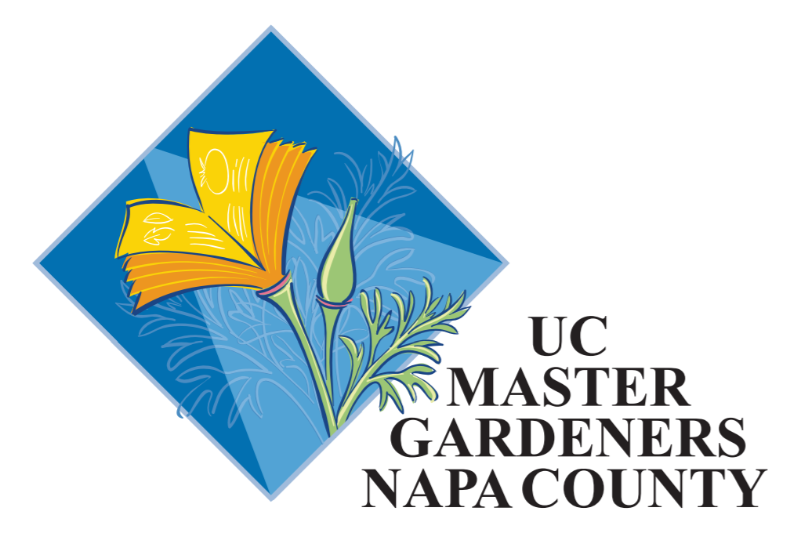

First: On your Internet search bar, enter NapaMG.org
This will bring you to the Napa Master Gardener Home Page. Then follow the steps as shown (In addition you can explore other gardening resources on each of these screens)
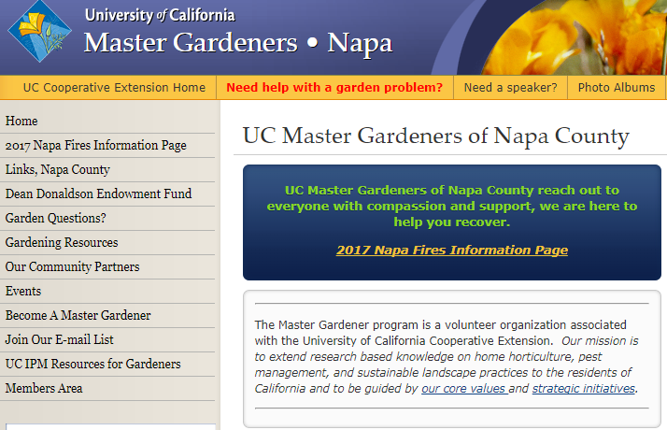

This will open up the following options: Click on “The California Garden Web”
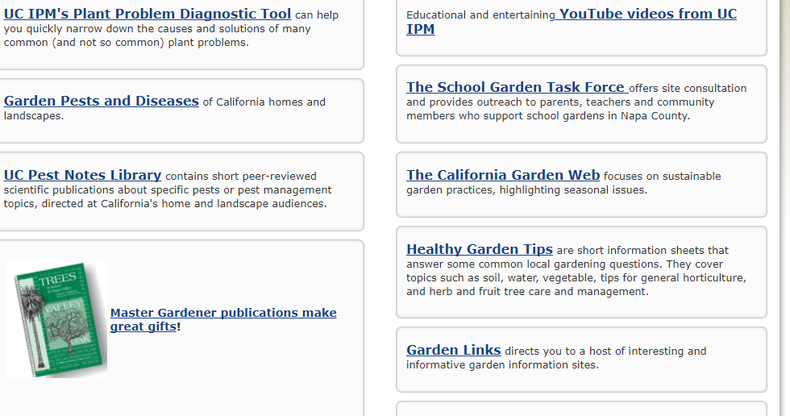

Then on the next screen, locate and click on “Vegetables”
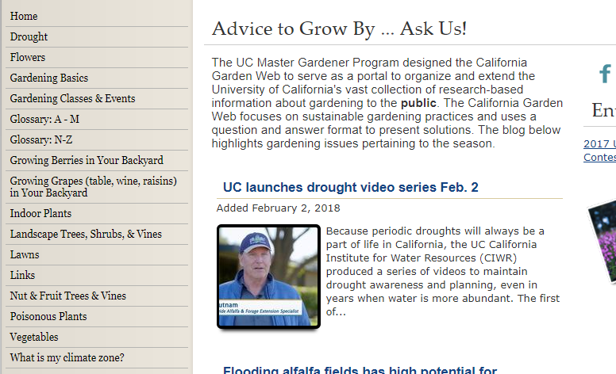
This will take you to this screen with a lot of general information. Scroll down to get a list of vegetables 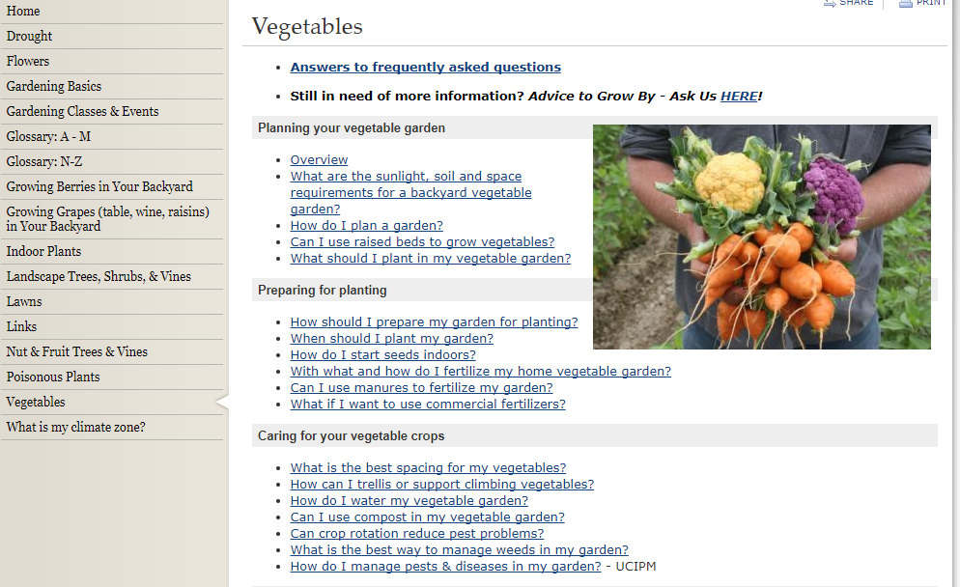
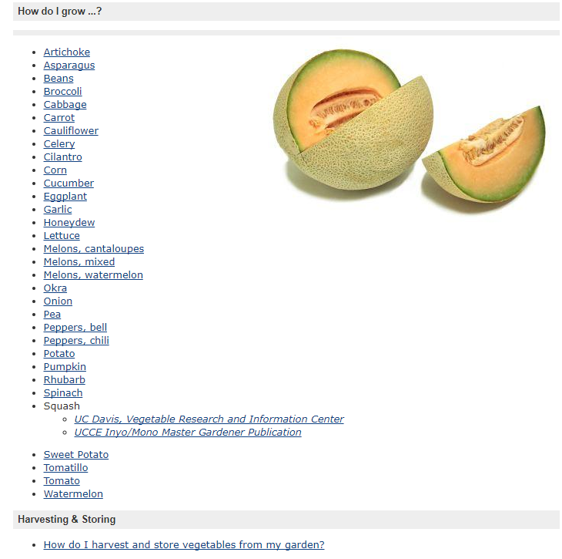
Click on a vegetable to display a pdf document to read, download, save or print.

