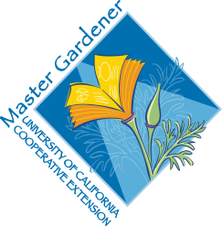

Assisting mother nature: amendments
We can be so focused on what happens above ground that we forget the importance of below the ground activity. Roots need to conduct enough water and nutrients for the most productive plant possible. Adding natural, organic, slow release products will keep those roots as healthy as possible.
1. Compost: Best would be, to make it yourself from your own plant waste; dry leaves and grass clippings for carbon, green waste or kitchen scrapes for nitrogen. This will improve soil structure and retain moisture.
- Bagged compost is also available, smells earthy, feels crumbly.
2. Most soils, whether valley or foothills, might need nitrogen because it leaches out with irrigation. It is essential for plant growth and stem production.
- “Seasoned” manure; chicken or steer. A bag may need to sit for 1-2 months to be sure it is seasoned. If too fresh, it can burn roots.
- Bat guano
- Alfalfa or Cotton seed meal
3. Phosphorus moves slowly in the soil; usually our soil is fine. Too much phosphorus may disrupt the mycorrhizal bond with plant roots.
- Bone meal
- Soft rock phosphate
4. Potassium promotes overall plant health, cell wall strength and development, flower and seed production.
- Kelp meal
5. Worm Castings are nature’s supper food, loaded with nutrients. A worm bin or two are easy, fun ways to nourish all your plants.
6. Soil Ph: Most plants grow best in a soil of 6.5-7. Neutral = 7. A healthy soil tends to neutralize an acid or alkaline tendency.

