**UC Master Gardeners of Placer County**   
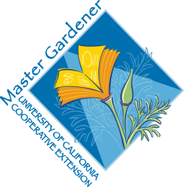University of California, Placer County Cooperative Extension

Spice It Up: Growing Herbs

# Public Website: [**http://pcmg.ucanr.org**](http://pcmg.ucanr.org)

# Questions: Hotline (530) 889-7388

# ROT Line (530) 889-7399

**RESOURCE LINKS**

Landscaping with Herbs – covers planning and planting an herb garden. (EHN15)

<https://ucanr.edu/sites/sacmg/files/116769.pdf>

Culinaary Herb Profiles – shows a plant by plant profile of commonly used culinary herbs. (EHN70)

<https://ucanr.edu/sites/sacmg/files/116768.pdf>

Integrating Culinary Herbs into the Garden

<https://ucanr.edu/sites/ucmgplacer/files/158599.pdf>

The Multi-Purpose Herb Garden

<https://ucanr.edu/sites/ucmgplacer/files/290859.pdf>